**Day 7 - AWS - Code Pipeline**

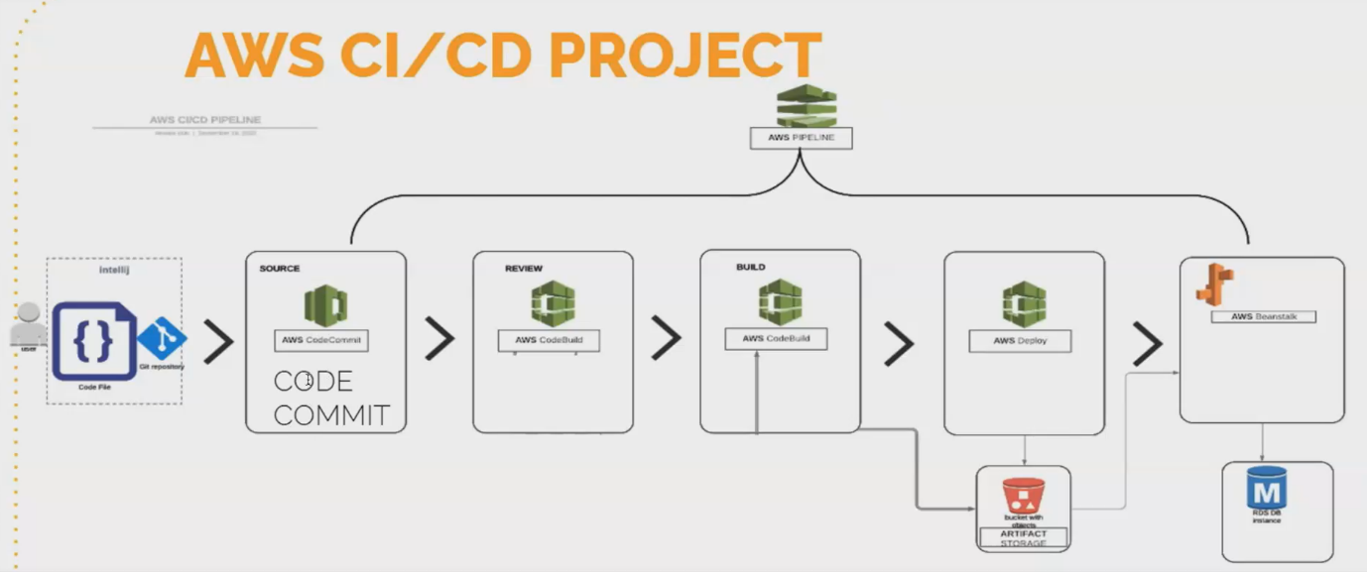

* we also have a similar tool like Github in the Aws. We call it as code commit. so where you can commit your codes like how you commit your code in the Github Repository. Same way in the code, commit repository.
* So, this is aws specific. So, you can only use it for the Aws specific projects. Here we put the application. You can deploy the applicant**.**
* **share your application, or you can maintain your application in this code [Commit repository].**
* if I want to build my application.but as a Java application, I build it using maven
* if I want to use Docker, I build it using my docker. So I will build it using another tool called code. Build here every stage for performing every stage in Jenkins you write a Jenkins file wherein here you'll be using different tools to perform the stages.
* We use code commit to build the application. We use code, build to deploy the application. You use a tool called Aws, deploy.
* **this aws deploy can deploy your application to any server.**
* So you can deploy it wherever you want inside the Aws environment and the entire flow can be automated using aws, pipeline, we call it as code pipeline. So using the code pipeline after building all the stages separately. The build stage deploy stage and the codec stage separately. You will integrate everything, using aws code pipeline.
* This is similar ro Jenkins file.

**Aws console:**

* code commit is similar to your Github Repository, wherein, in your Github Repository, you can create public repository and private repository.
* Wherein code comment, you can only create private repositories which is specific to certain users only for the authenticated user can access this code commit repository like it will ask you for the username and password to access your event, to clone your application from the code.
* Commit repository, you need permission. So this is a private repository wherein you know Github is both private and Github. You can create both private and public repositories.

**How to create aws pipeline:**

Search code commit in aws console

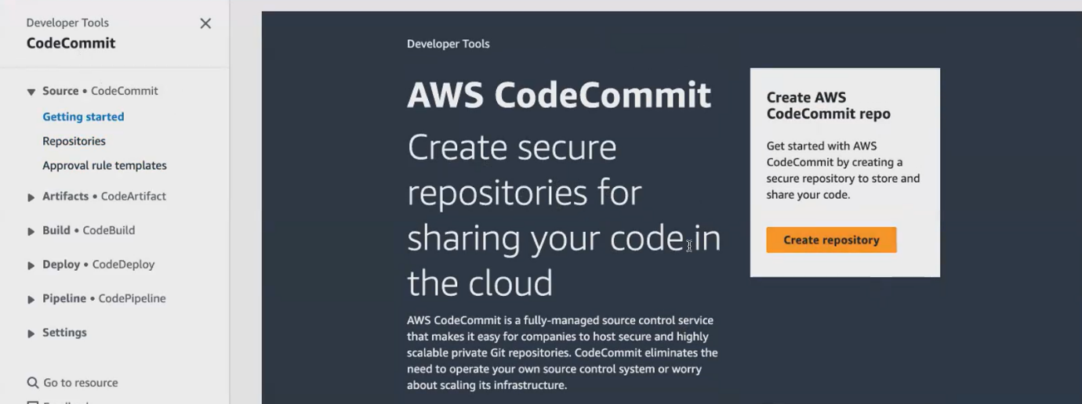

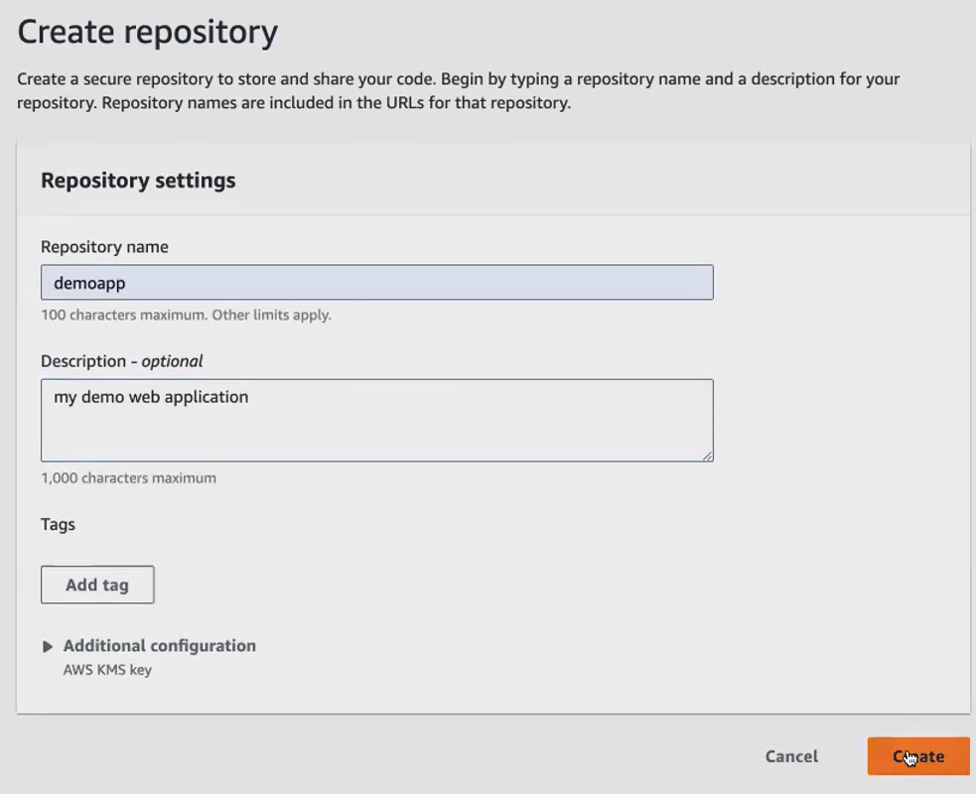

Similar github command used here.click this URL can be coiped

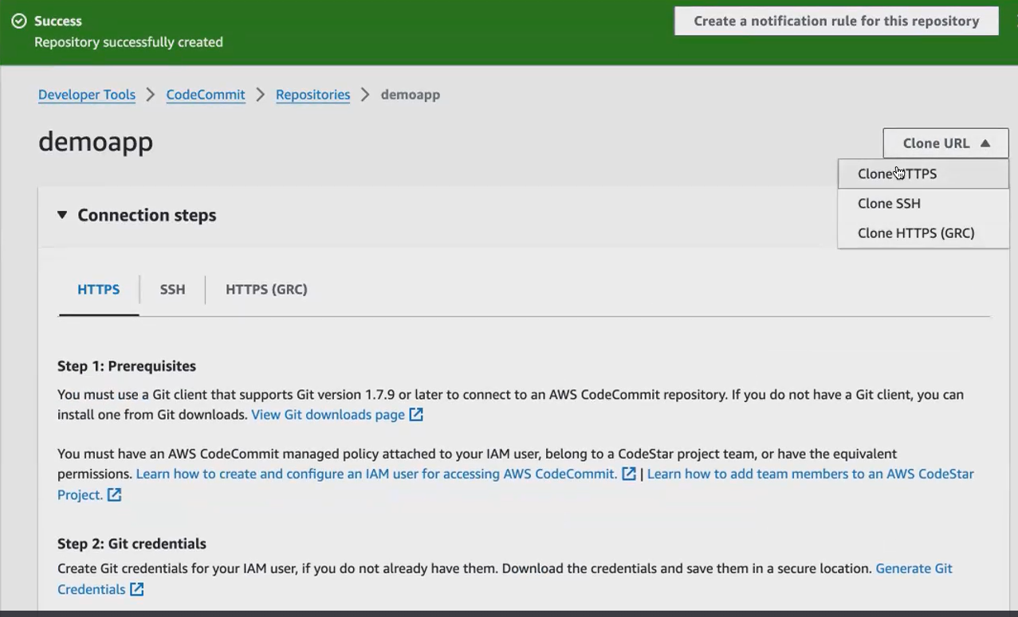

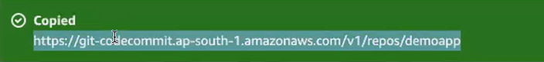

Click ec2 ,open in new tab.

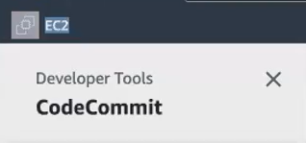

Launch an instance and connect

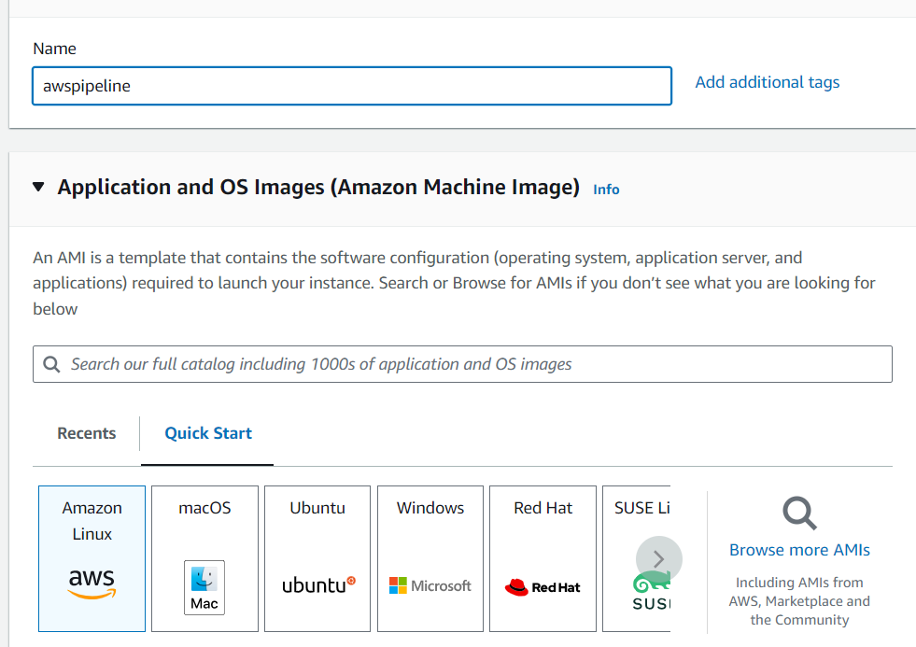

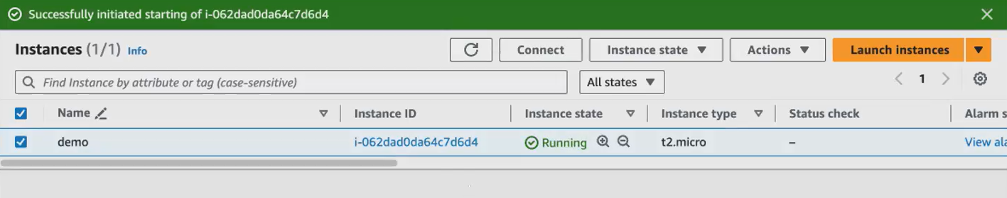

Connect with that instance and install git

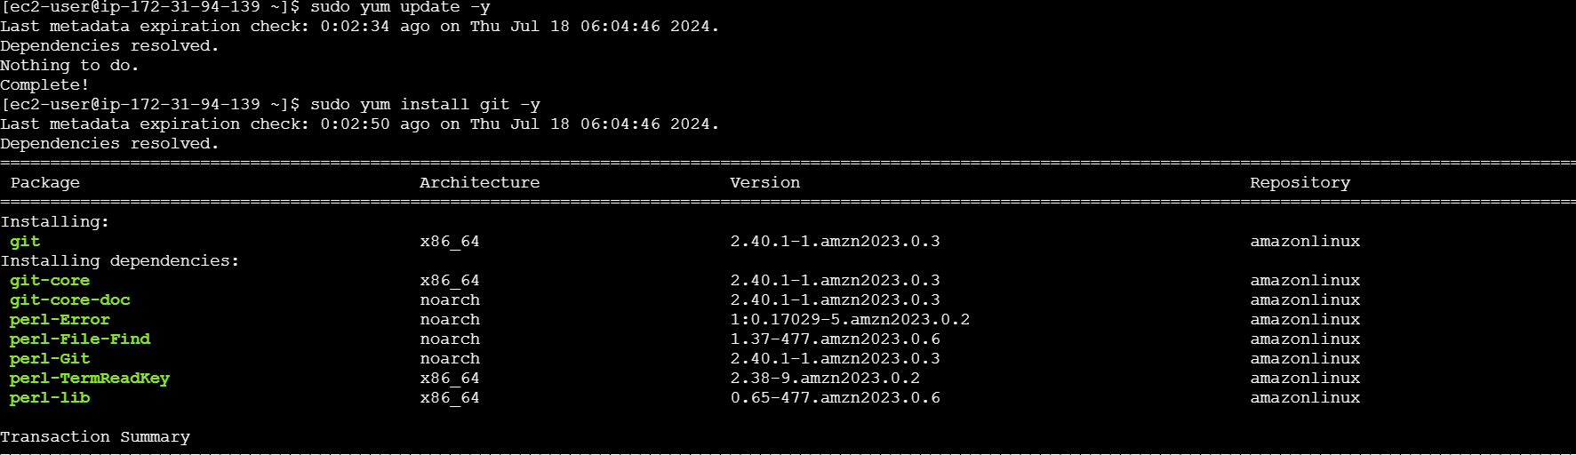



Clone the created repo in amazon linux.that link taken from codecommit repo we created.



if you're using a private repository to ask you for the username and password every time. If you want to clone that private repository will ask you for the username and password same way. for that, you have to go to the IAM.

**How to create iam user:**

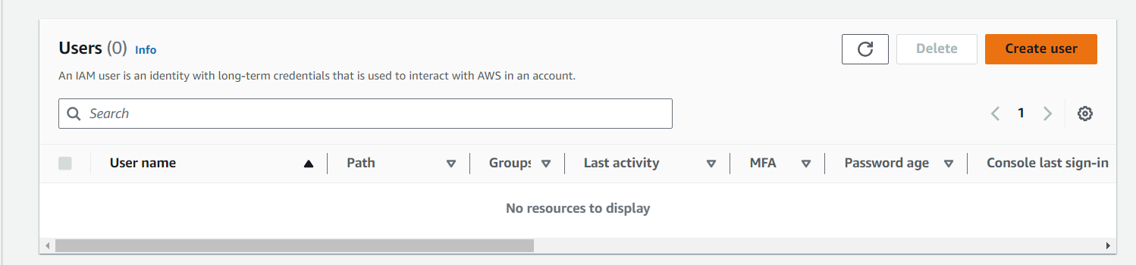

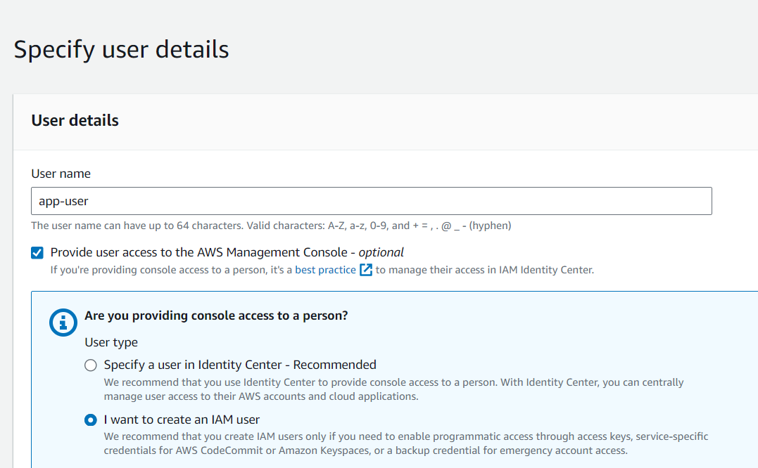

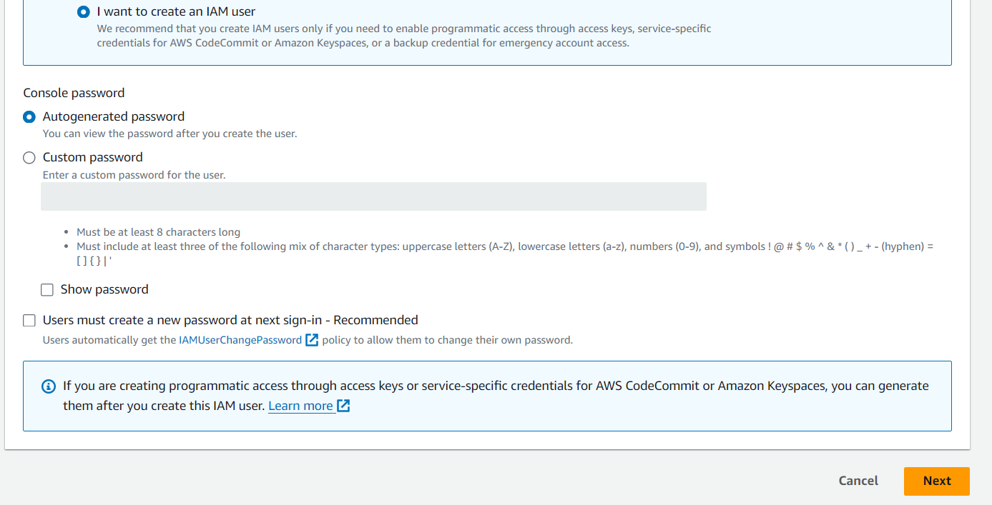

we have to attach policies.we only use so give administration full access

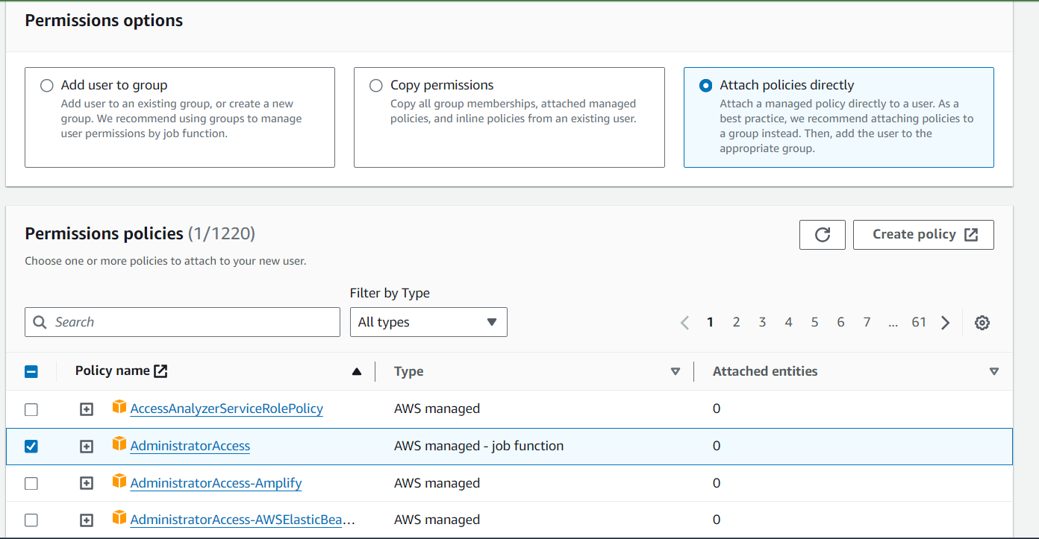

Click next

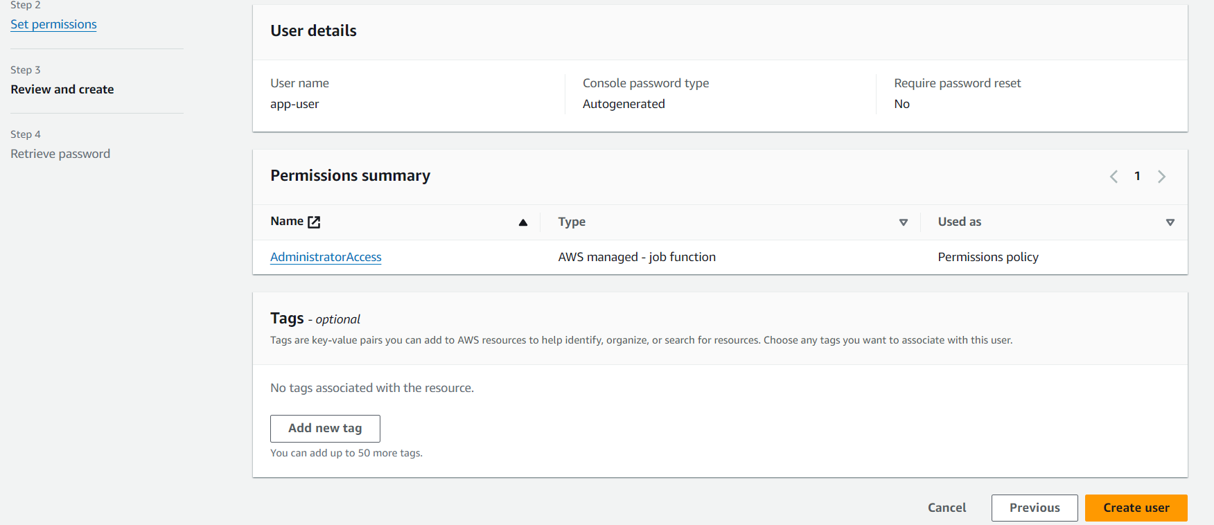

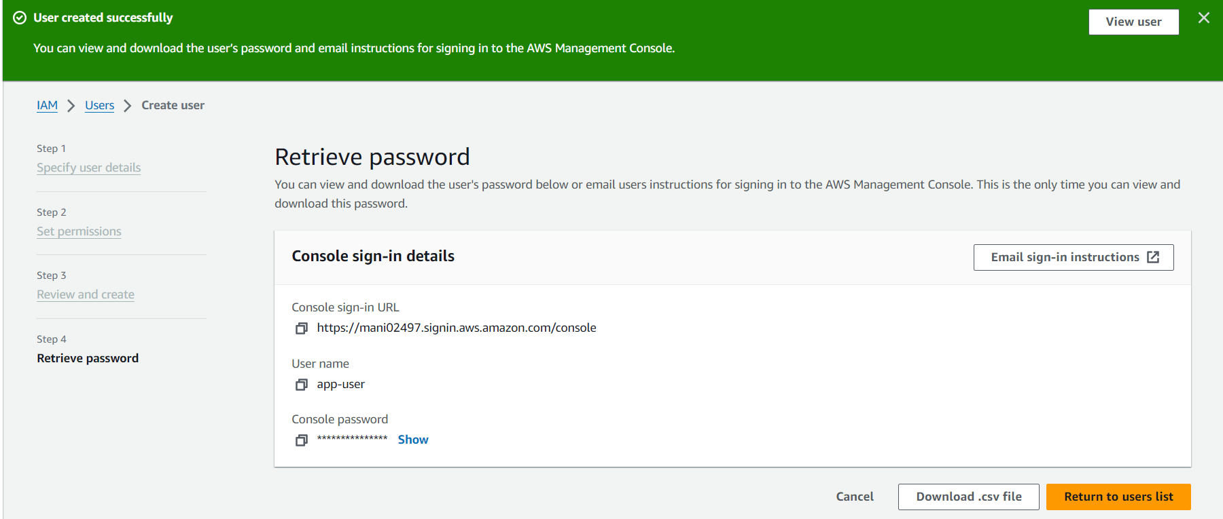

Goto IAM user

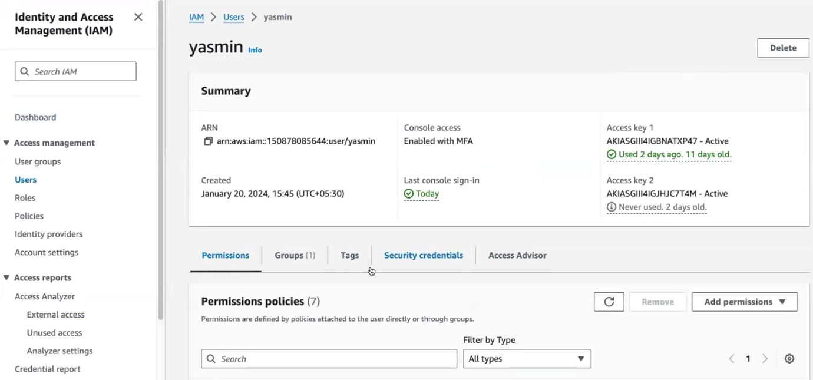

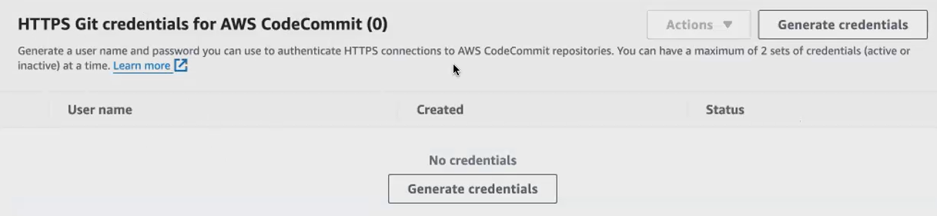

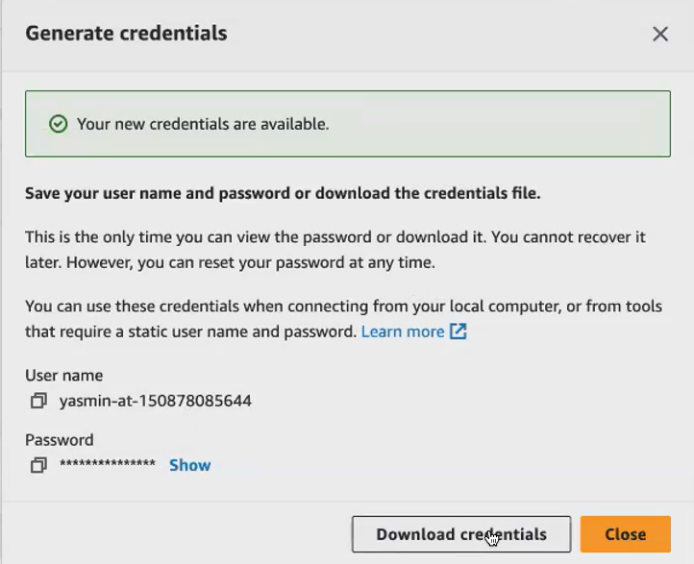

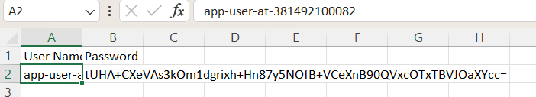

Open download credentials in excel.

Copy username and password in **amazon linux**

now you can see you have appeared to have cloned the empty repository. So now the repo is cloned. You can see Demo app is the name of my repo, which is an empty repository. Okay, I have cloned it now. So let me give cd to get into it. Now, this is an empty repository. I don't have any files or application. A so now, what I will do, I will be putting some application to this repository. Okay, so now we will create us

Inside demoapp repo we added few files

1. Index.html
2. Buildspec.yaml
3. Appspec.yml

install_nginx.sh

Start_nginx.sh:

1. **Index.html:**

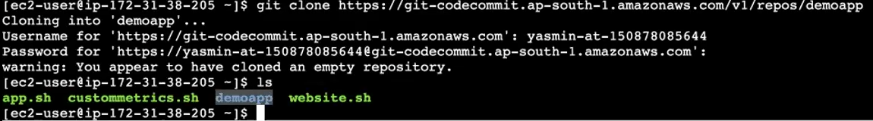

I will launch a simple index.HTML page. okay. So here in this index.HTML,you can give any content to it. So this is index dot HTML page, which will display Hello devops on my browser when I execute it. Now I have this index.HTML page, and to run this in the browser. You need a web server, so I will be using nginix for that.

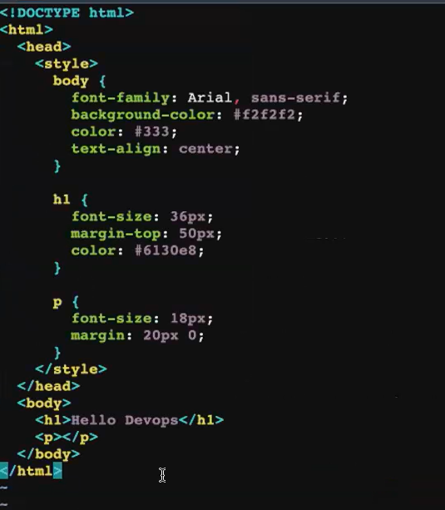

**Your code commit repository is created, but it's empty. Nothing is there? So what I will do? I will push this index.HTML**

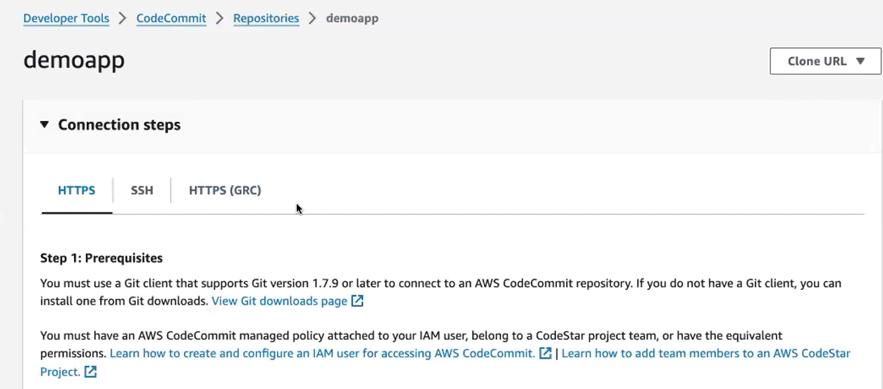

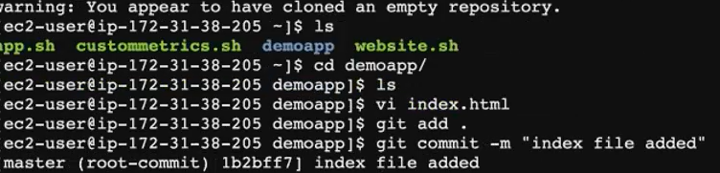



**now you're doing a push to the code, commit repository. Again, it will ask you for the username and password. So I think I've downloaded the username and password. I've downloaded the code commit credential. Just copy the credential and put it here so like how you, whenever you're making a push to the Github Repository, it will ask you for the username and password. Same thing you have to do it here.**

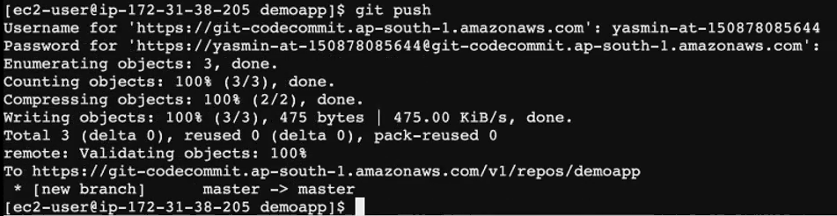

now the index HTML. Is moved to the code, commit repository, go to the code, commit repository. We give a refresh

Already we create a demoapp repo, then clone that demo app repo. Inside the repo we have index.html application file. We use that application.

your Github Repository can be a public report, but here it is only a private report. So to access this, you need to have an Iam user with a code commit credential. So to access your code commit repository. You have to be an Iam user. And you should have this code commit credentials[ssh ,https].

Now in the master branch.

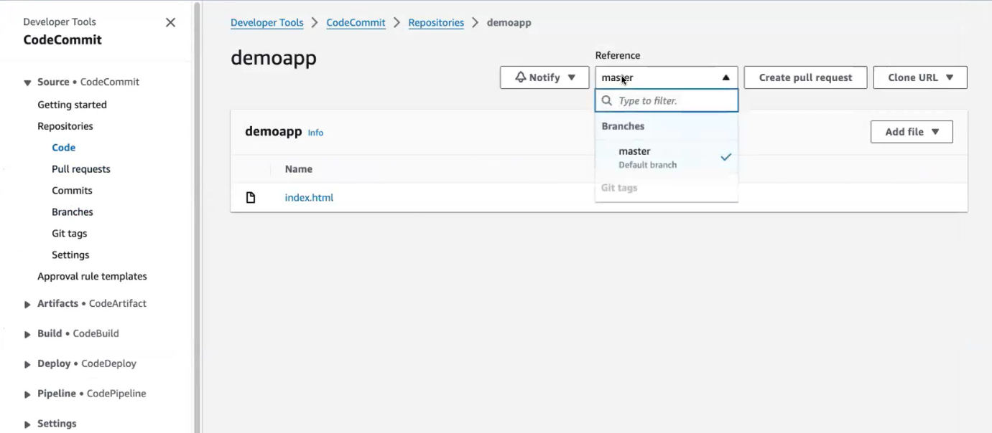

Smiliar to github we create a branch[if we need]

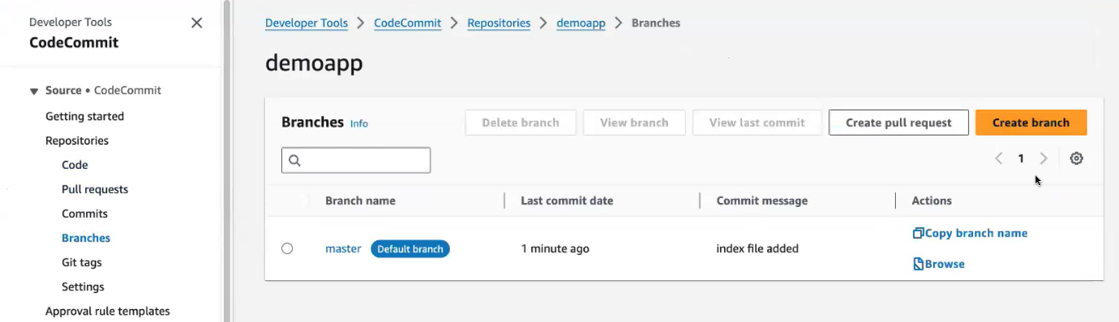

before creating project doing the build. Okay, I have to mention how to build the application. I have to tell my code build how to build the application. you have to write a file called **buildsepc.Yaml**



**So in Jenkins you'll be creating only one file. That is your Jenkins file in the Jenkins file itself. You will be writing all the you'll be creating or configuring all the stages, build stage test stage and the deployment stage in one file.**

**you'll be creating 2 separate files**

1. **for building [**buildsepc.Yaml]
2. **for deploying [aspect]**

We we have the HTML file, and if I want to access my HTML file in the browser. I need a web server, so I use ngenix for accessing this index.HTML, file. If you're using a full fledged application like python or react application.

1. always, your build respect file starts with **version**
2. what all I have to do to perform my build. Okay? So that I will put it inside **phases.**
3. before doing the build. if it is a Java application before building the Java application, what you have to do, you have to install the build tools. So I have to 1st **install my builder tools.**
4. since it's a simple HTML application for this.If you want to build the application , u need only **nginx[build tool for HTML].** If you're using a Java application, then we will be installing Maven.
5. here I will just simply give a simple **echo command** I'm installing in the next server.So these are list of commands in Yaml, if you give if you start aligned with the hyphen [-], which means you're mentioning a list.
6. Next give sudo .after updating, you have to install the nginx application.
7. after installing the necessary tools, you have to **build your application** for building your application.
8. just mentioned today's date.So here I've used my index.HTML, so I have an index dot. HTML. What I'll do. I'll simply **copy my index.HTML page** to my web rute directory of my Internet server. So the Web Brute Directory for your Internet server is /var/www/html.so inside this folder I have to copy my index.HTML. So when I execute my Internet's web server.
9. In post build commands ,this echo statement is just for the clarity. when this build is executing. You can check the event, page or logs page, to see what are the actions it is performing, so when you give echo it will be helpful for you to understand in which phase it is exactly running the build.
10. after building the application, usually what you'll get you will get the artifacts. So if you're building a Java application. You will get the jar file. Okay, inside the target folder. You get the jar file so what you can do. You can move all your jar files into your S 3 bucket.
11. **in this application you don't have a jar file. You're only copying the index or HTML to the Web Root Directory of this Engine nginx web server.**

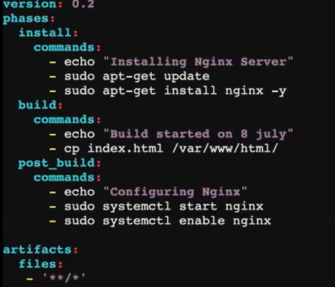

Now let me save this file and where I have to maintain this file, I have to push this file to my code Comment repository. Okay? So for performing your code build, you have to write your **buildsepc.Yaml** based on the applications requirement. We will be writing it.

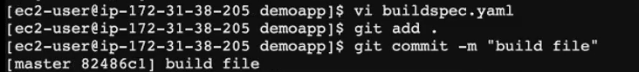



**now the buildsepc.Yaml** **is moved to your repository.**

**Inside repo we have 2 files.**

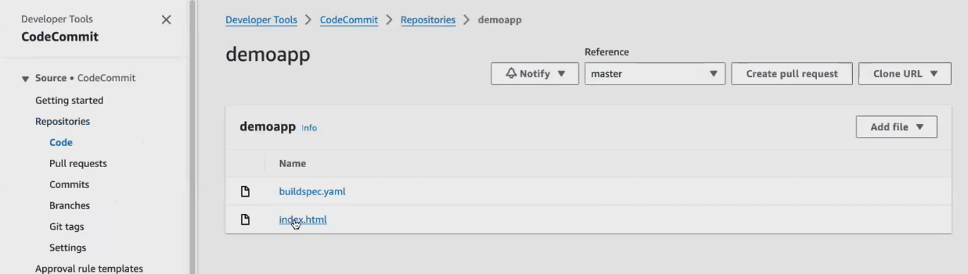

Then built that code using code built. **this code build is used to build and test your application.**

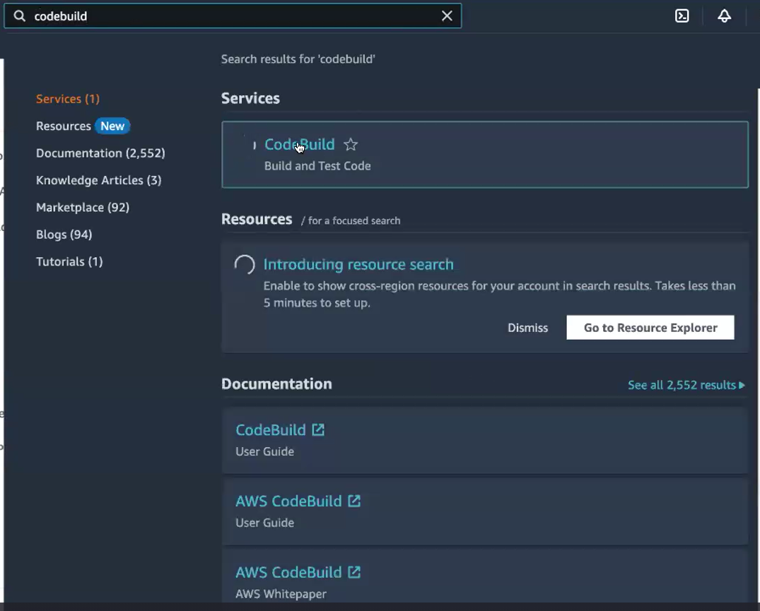

**click on, create project under your code, build to build your project. You have to click on, create project**

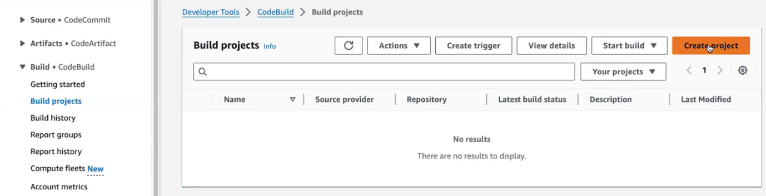

**here your application is located. Now my application that I have to build is located in the code Commit repository. You can also, if you have the application in the Github Repository, you can also click on Github. Okay, now, I have my application in the code Commit repository. So I can select the source as code Commit .**

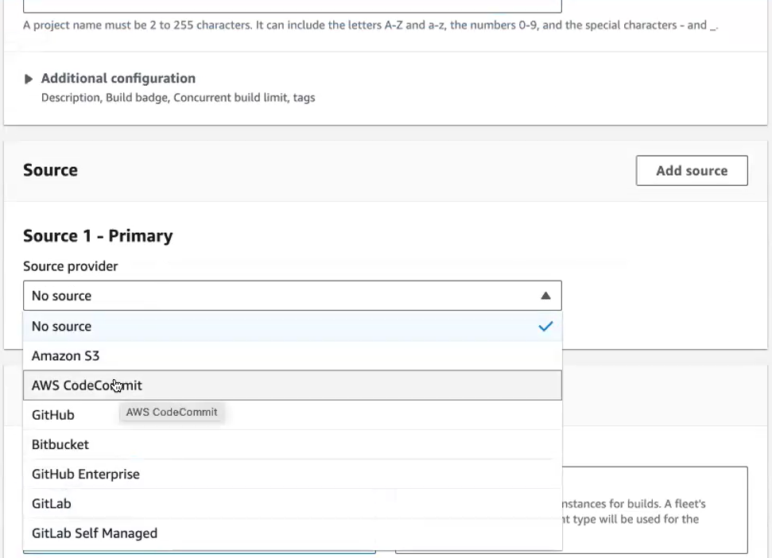

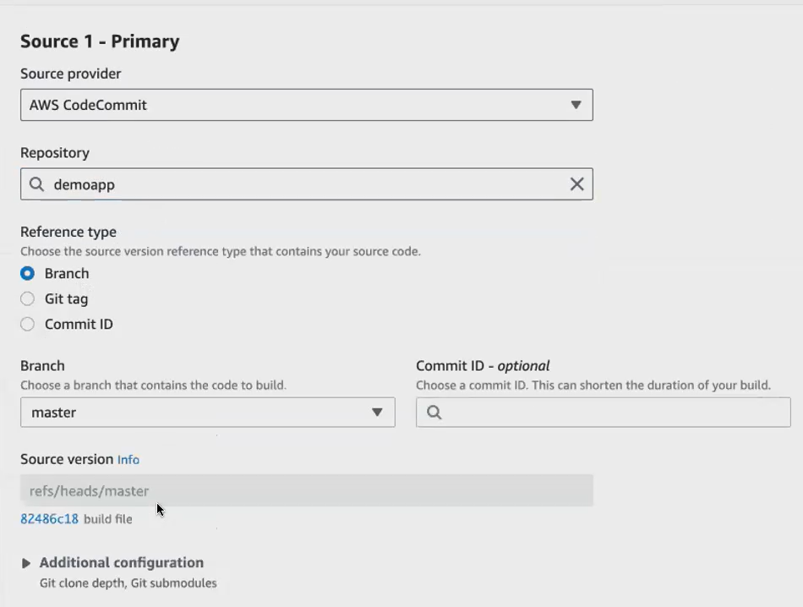

behind the what you need, you need an Ec2. You need a compute server to perform all these actions. So code build, it will create. Okay, you cannot see that machine getting created in the Ec. 2, dashboard. But behind your code build will maintain a Ec 2, it will launch a Ec 2.

Give ubuntu server ,because in amazon linux sudo apt not work its shows error. Remaining as given.

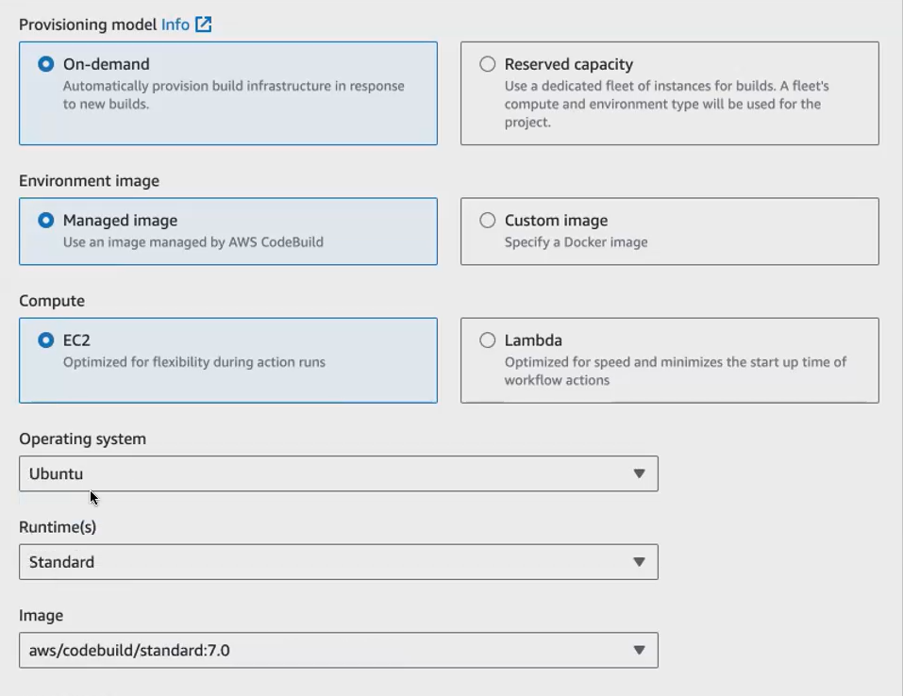

**if you're doing it for the 1st time you have to create, go with a new service role. Service role means what this build is doing. Code build is doing. It is talking to the Ec2 , so it has to connect with a different service. service role is mainly for connecting 2 different services. In IAM give this service role.**

**My screen:**

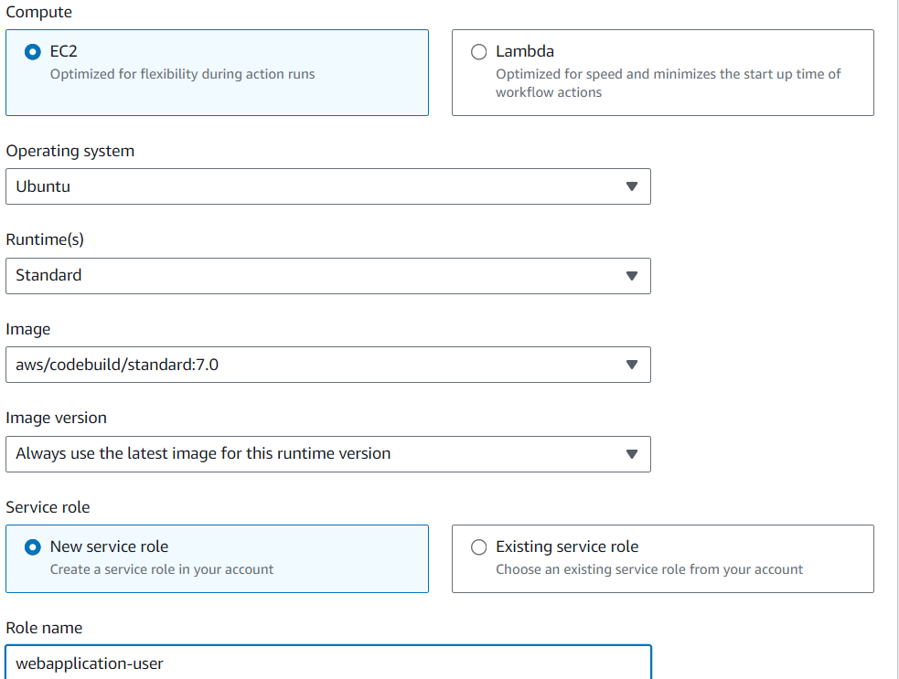

**Yasmine screen:**

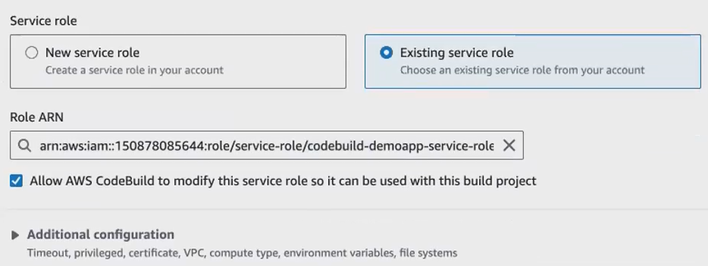

Write our buildspec file in this also by using insert built cmds

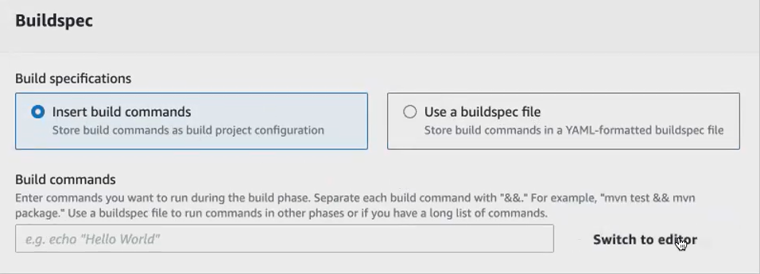

Write the code in this also.

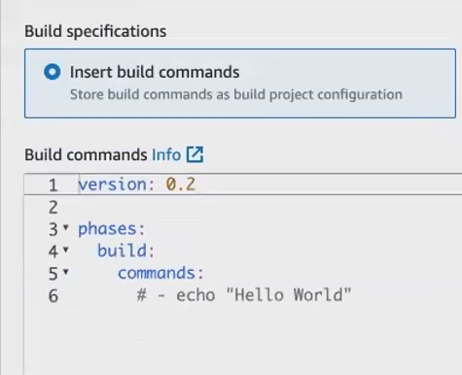

We have already write buildspec file.so use this from code commit takes that file automatically. **automatically fetch my build spec file based on the build spec file, the project will be built, the application will be built.**

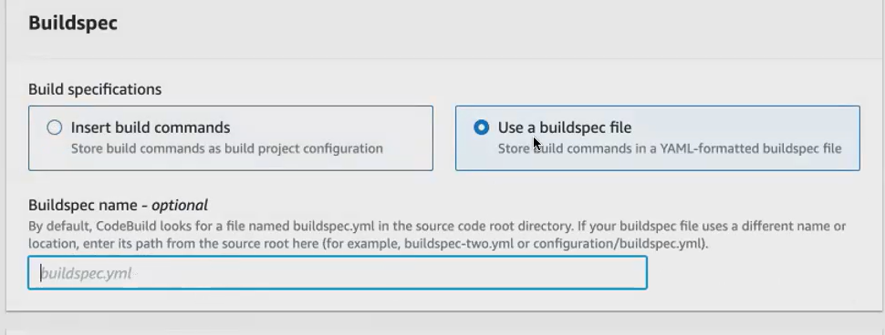

Artifact asks in which s3 bucket stores this.so we create s3 bucket..yasmin used already created s3 bucket.inside that bucket create folder called artifacts..inside that folder my artifacts file stored.

**I created s3 bucket [sharmi-pipelinebucket].inside that artifacts folder created**

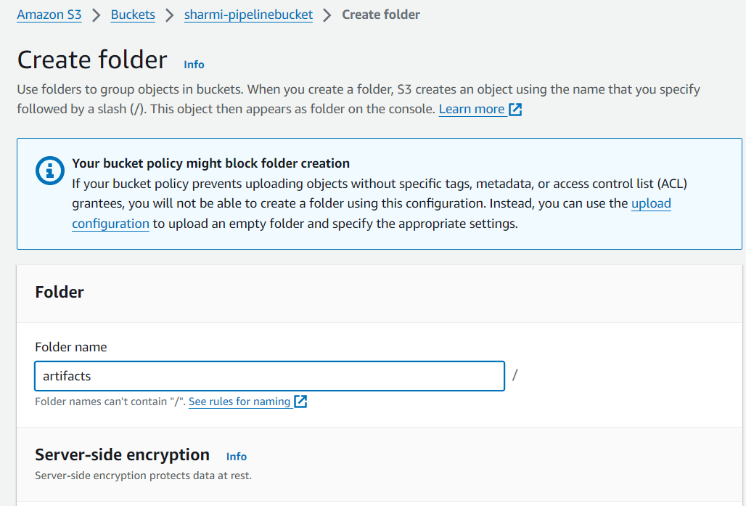

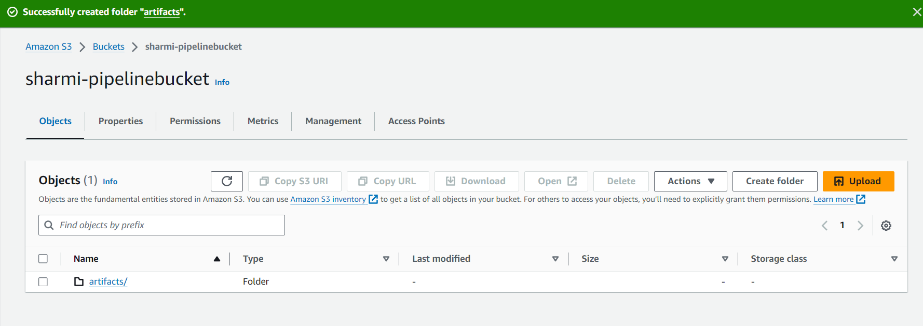

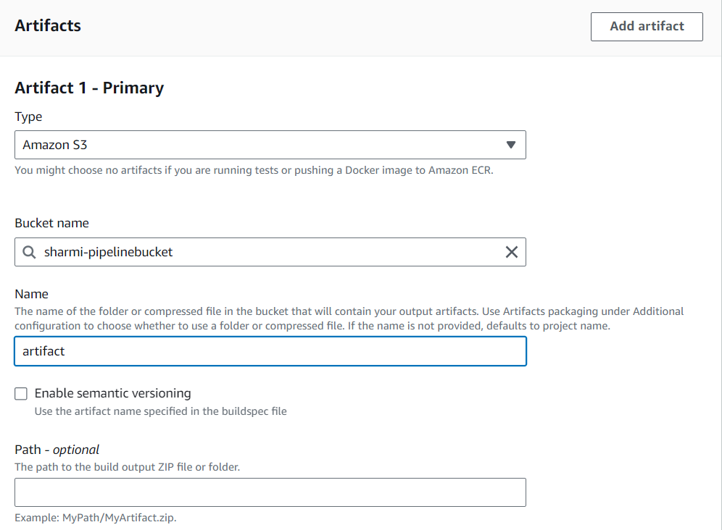

Want our appli in zip format give zip.

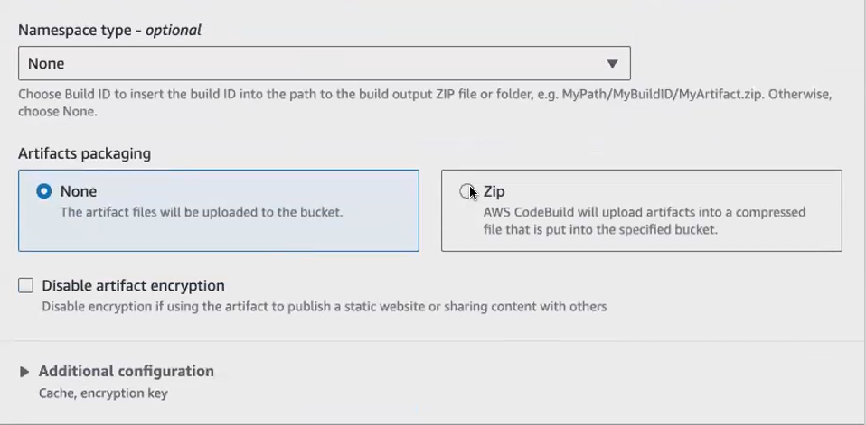

our cloud watch will keep on monitoring your application logs. Okay, you don't want it now, because it will charge you for that.

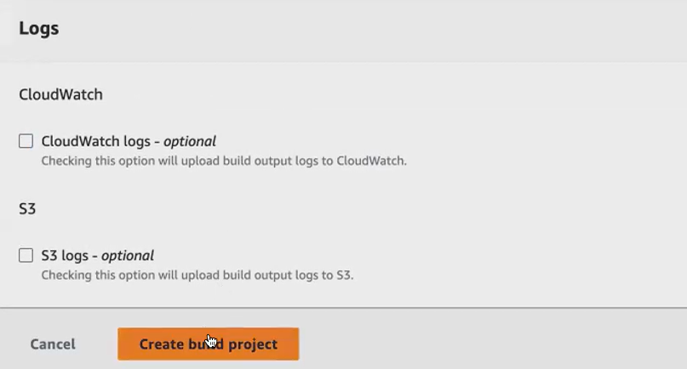

Click start build application can build.

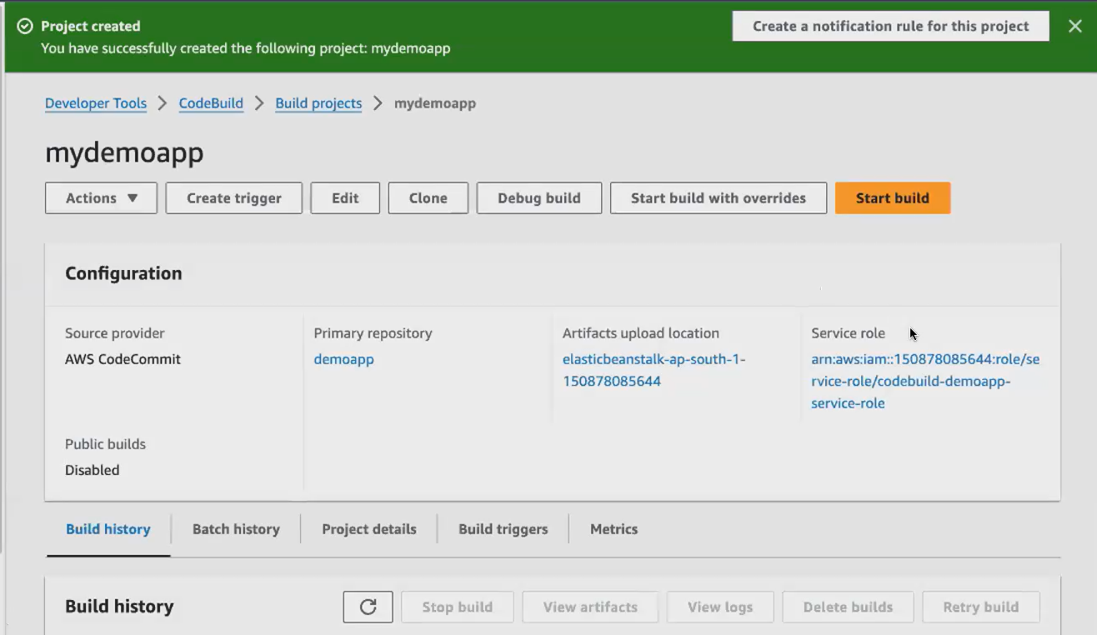

My screen:

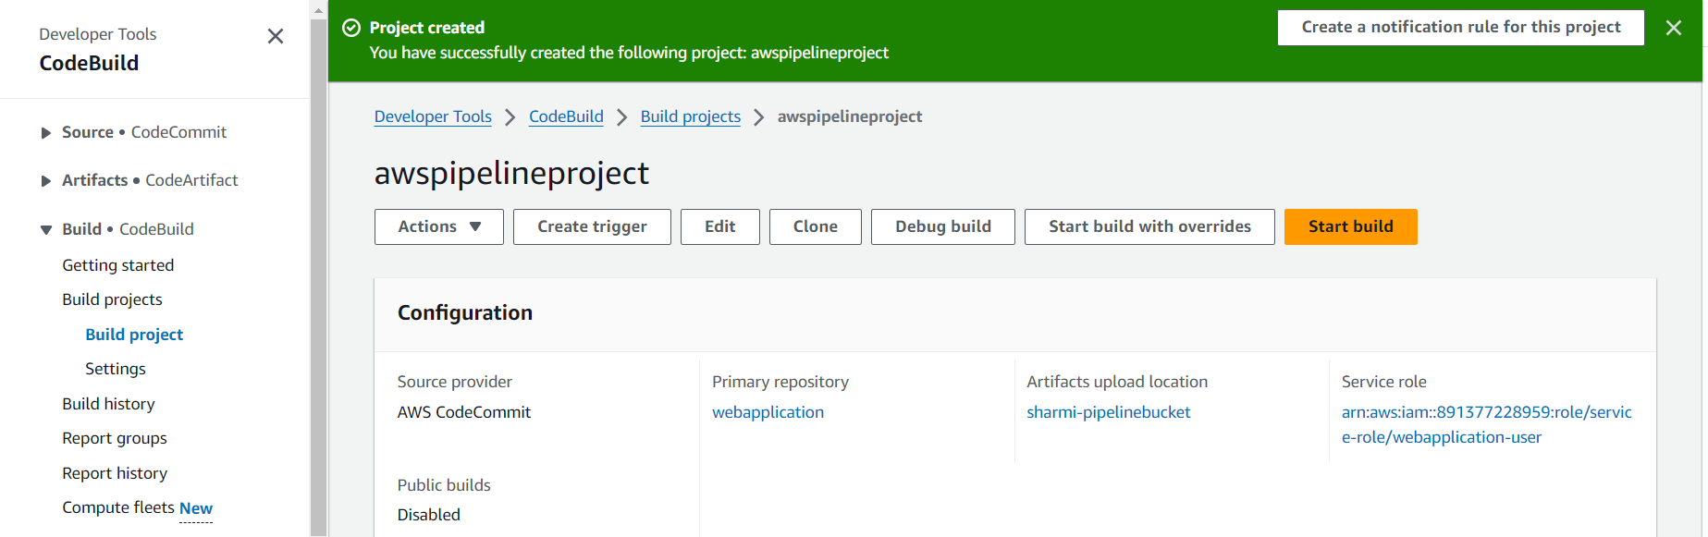

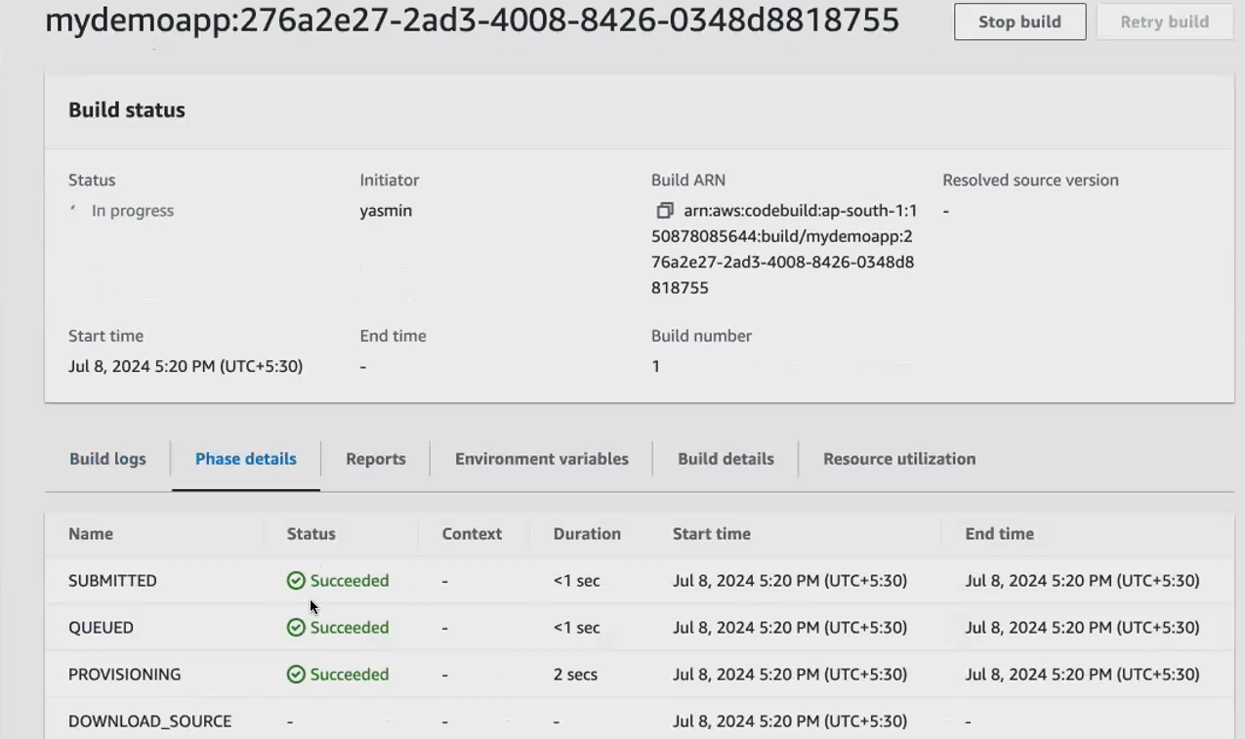

One by one all stages can built .suppose shows an error goto repo 🡪 code🡪edit

Line 15,16 shows error ..so remove that lines.

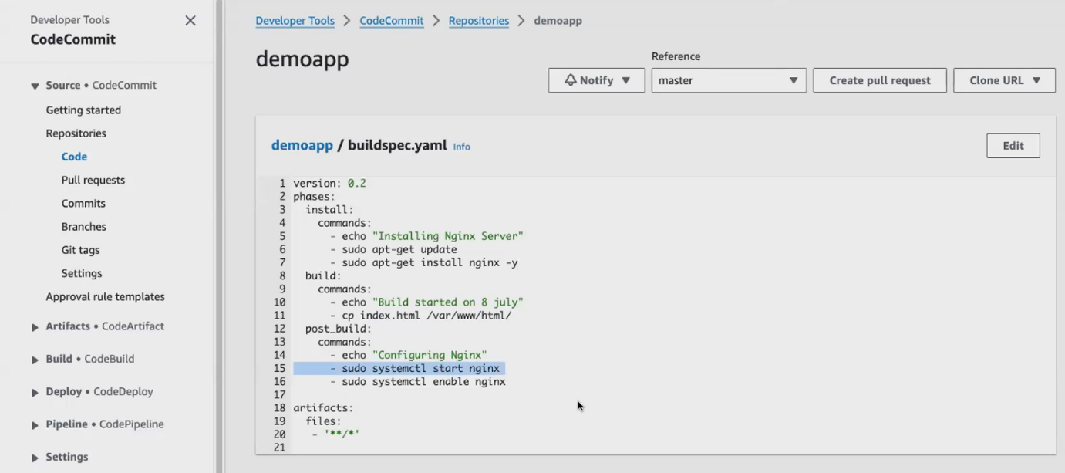

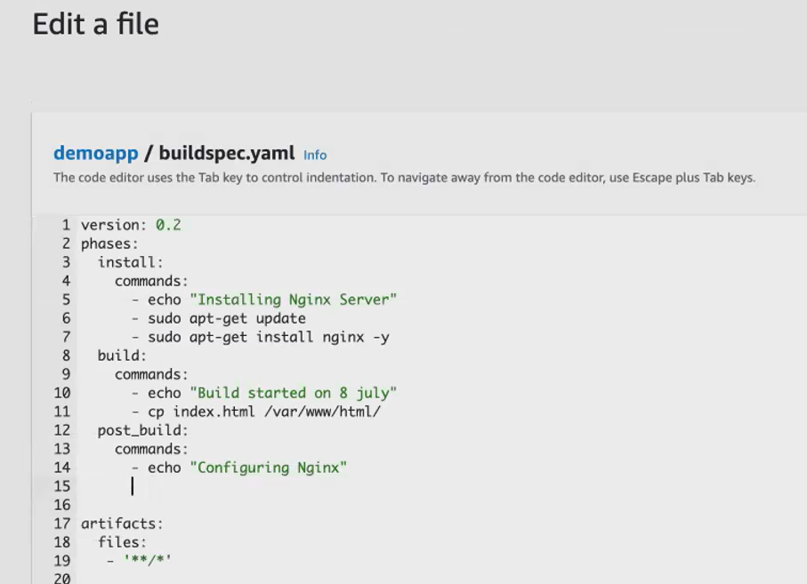

Click commit changes.

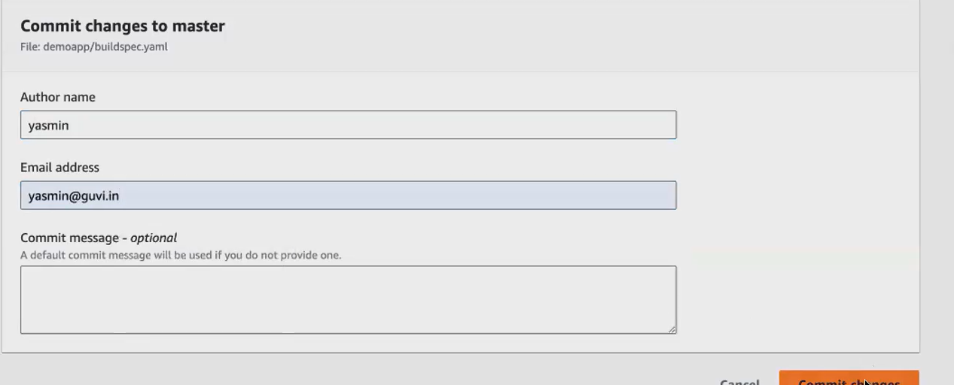

again goto build projects🡪click start build

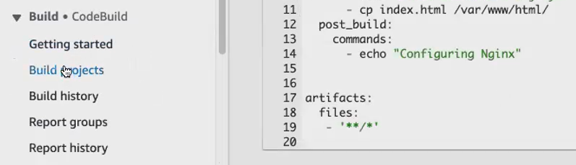

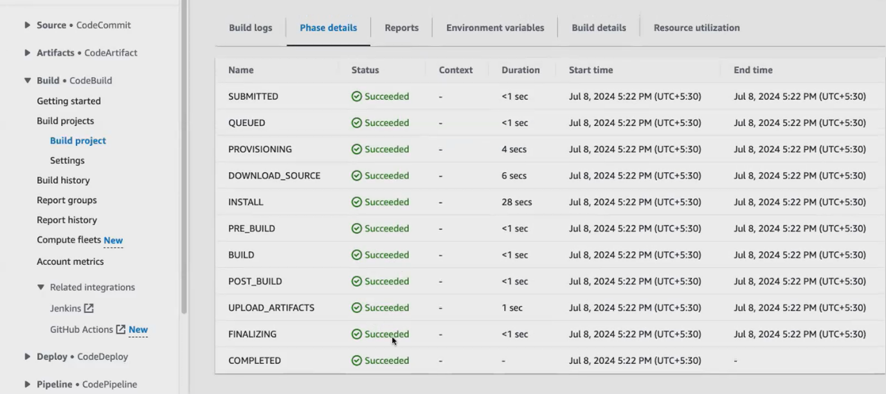

Now application is build.

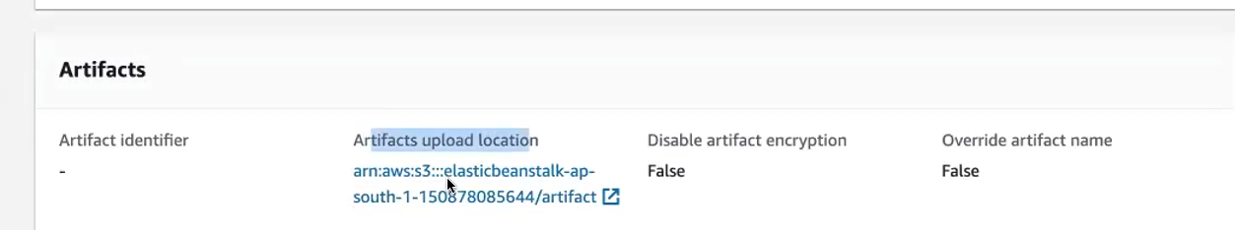

We build the application we got artifacts.

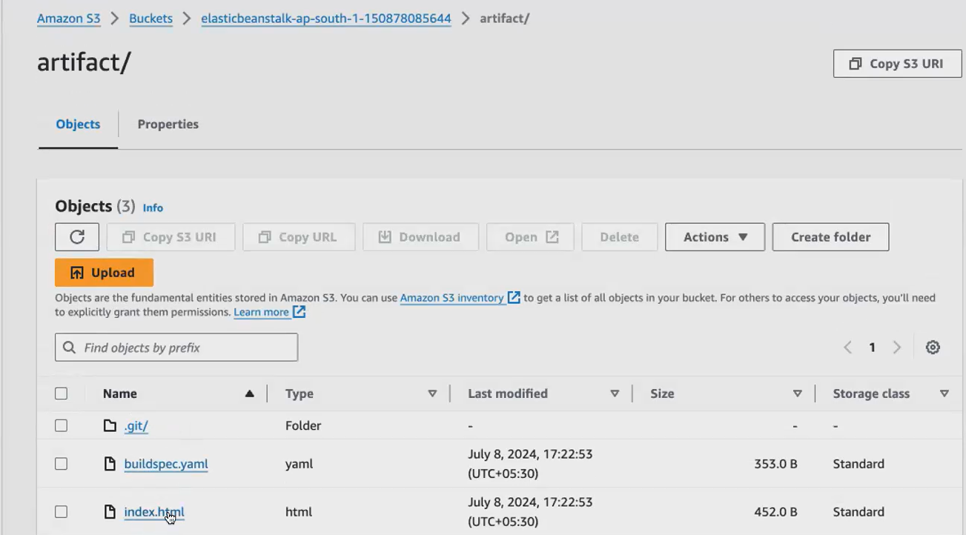

After build deploy the application.

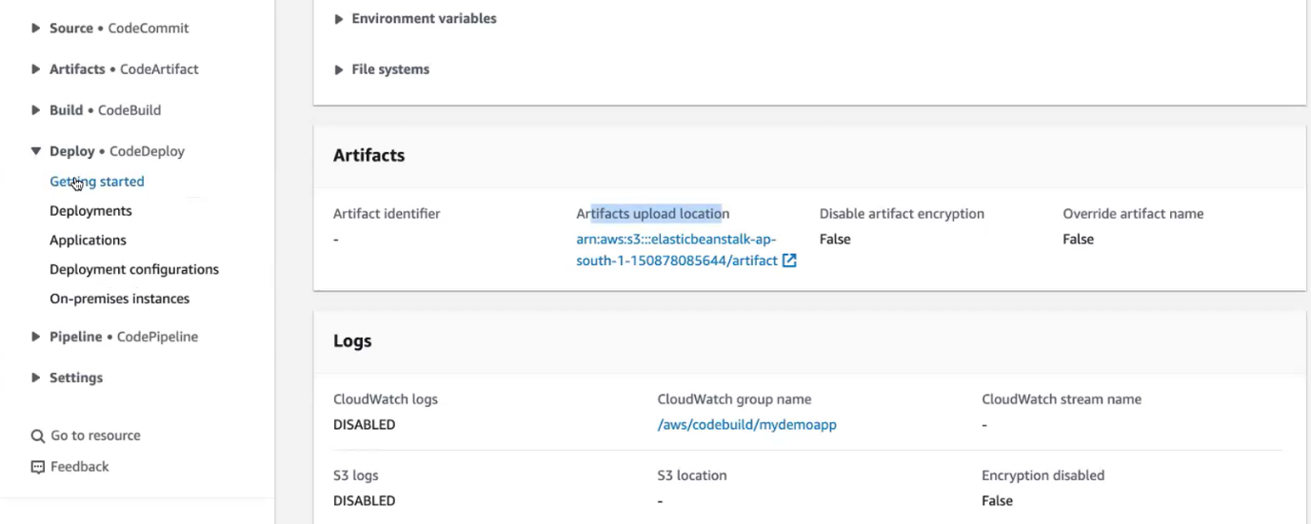

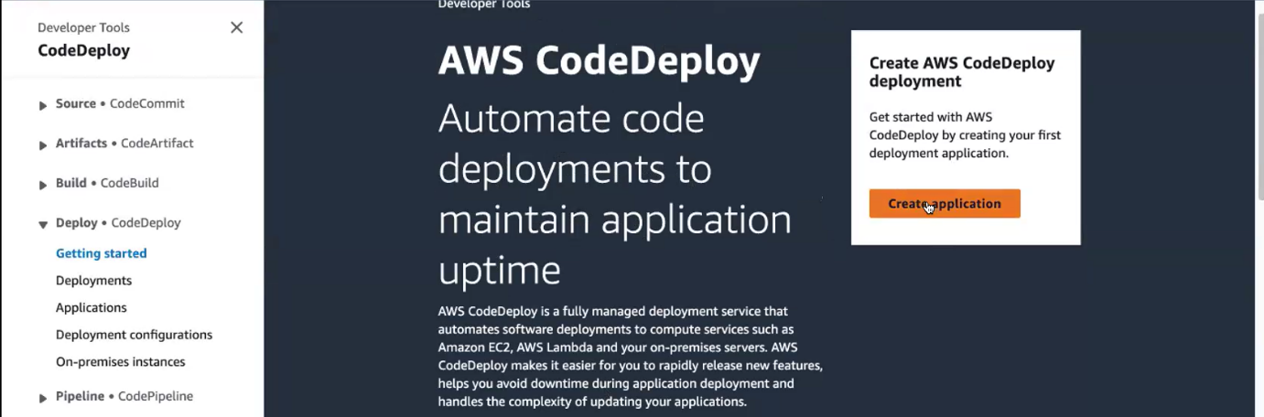

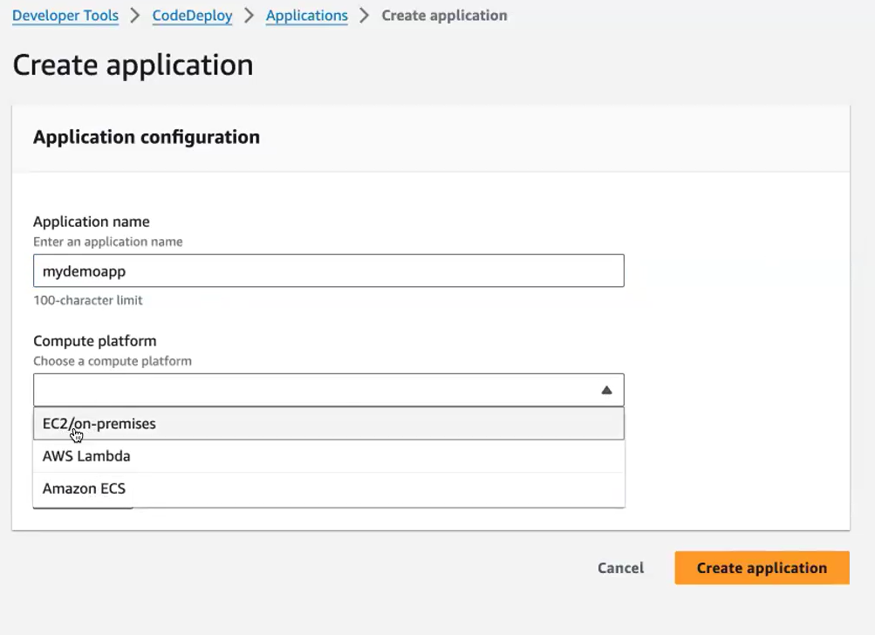

**you can see you can see your server running this deploying, this application to the Ec2 .If you want to maintain a serverless architecture, you go with Aws Lambda.**

now I have created it. We have to go and **create the deployment group**. So after creating your application, we have to go and create the deployment group. So your code deployed can deploy your application in one ec2, or if you want to deploy it in the real time, we don't deploy a application in one ec2. We will be deploying it in multiple machines. Okay, so that is why we call it as deployment group.

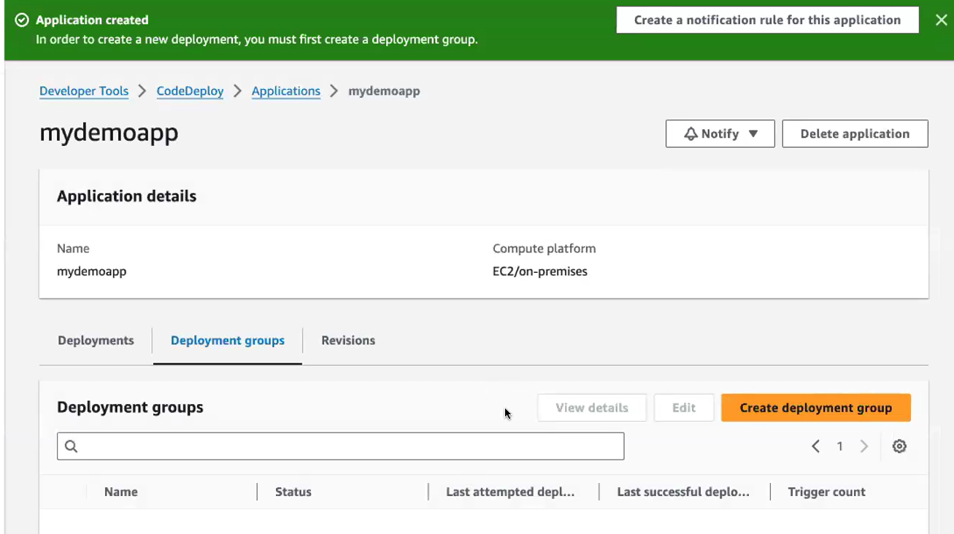

**Service role we have to create:**

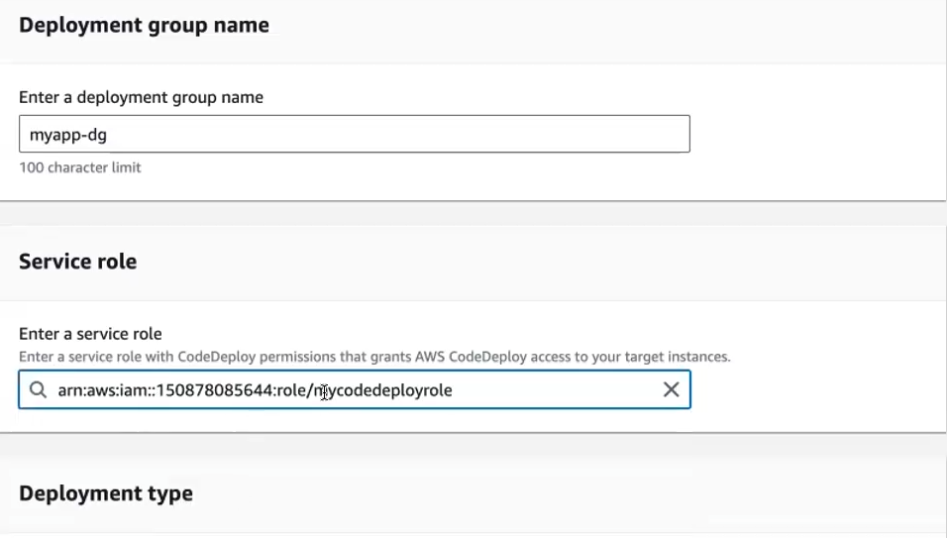

**How to create Service role:**

**Goto IAM 🡪 click create role🡪**

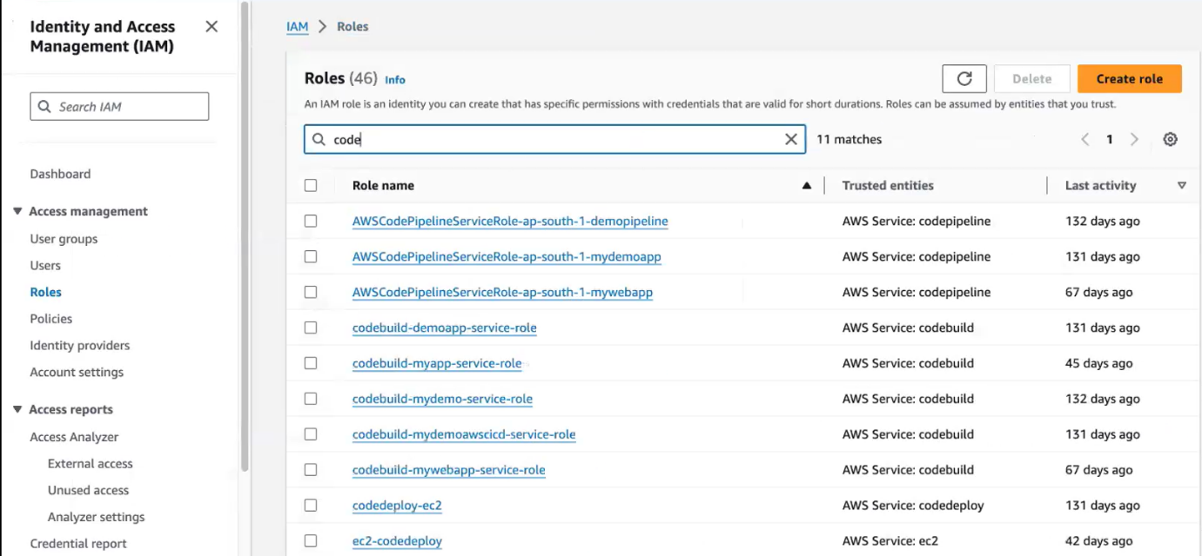

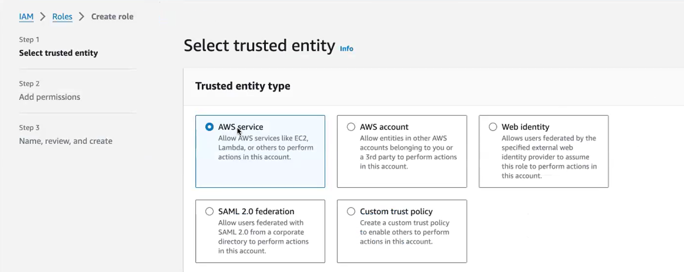

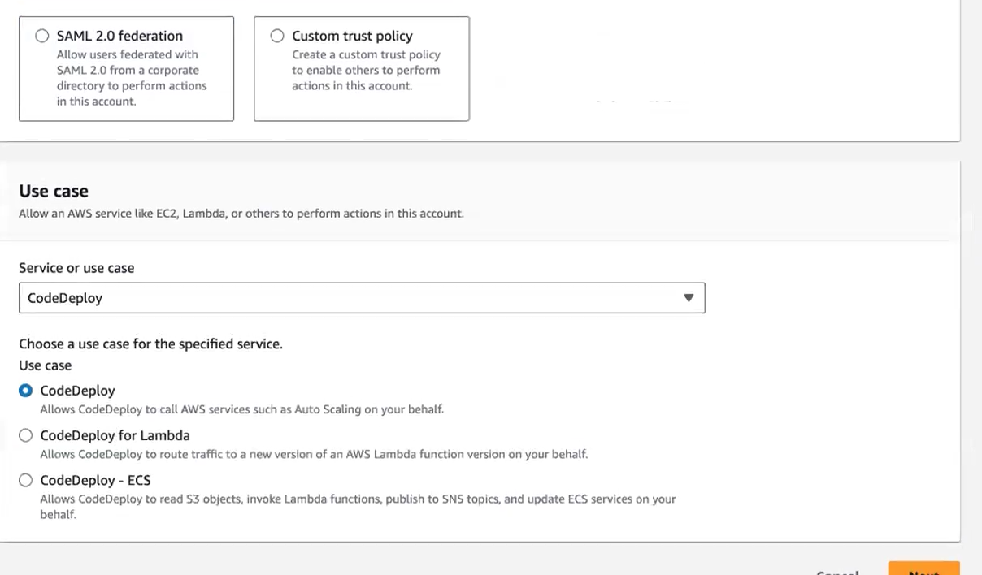

Later on give permission

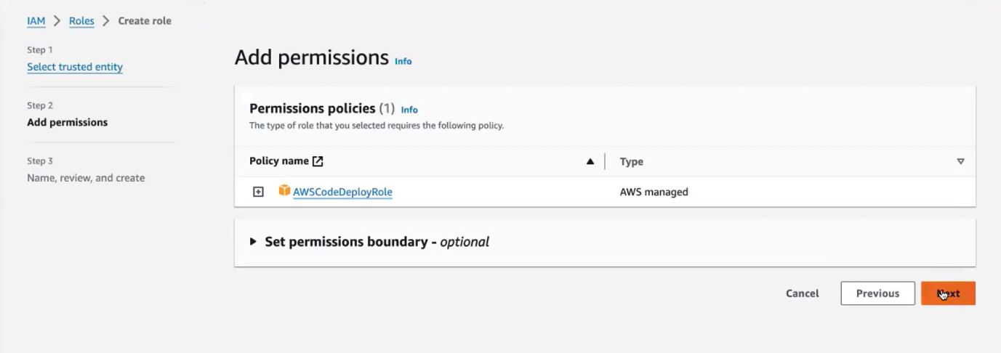

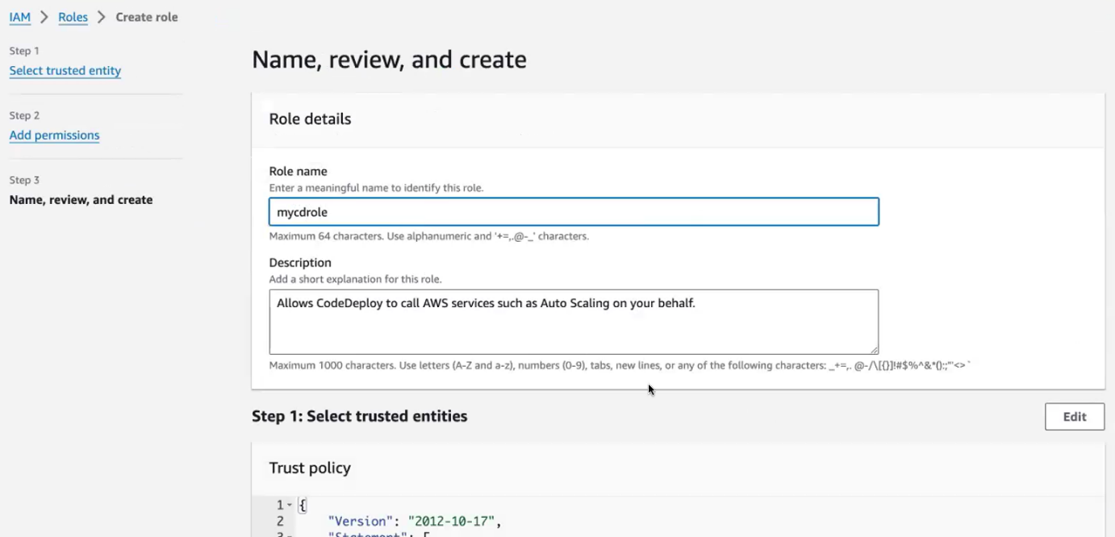

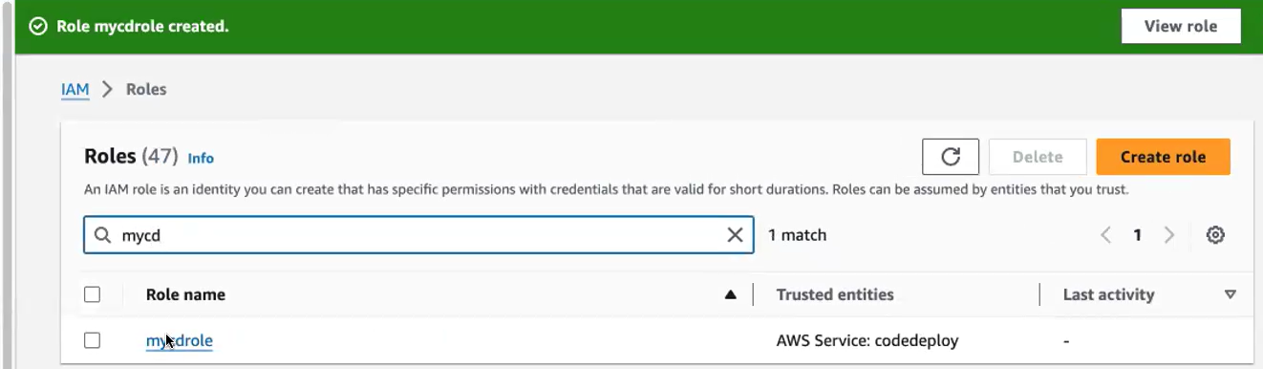

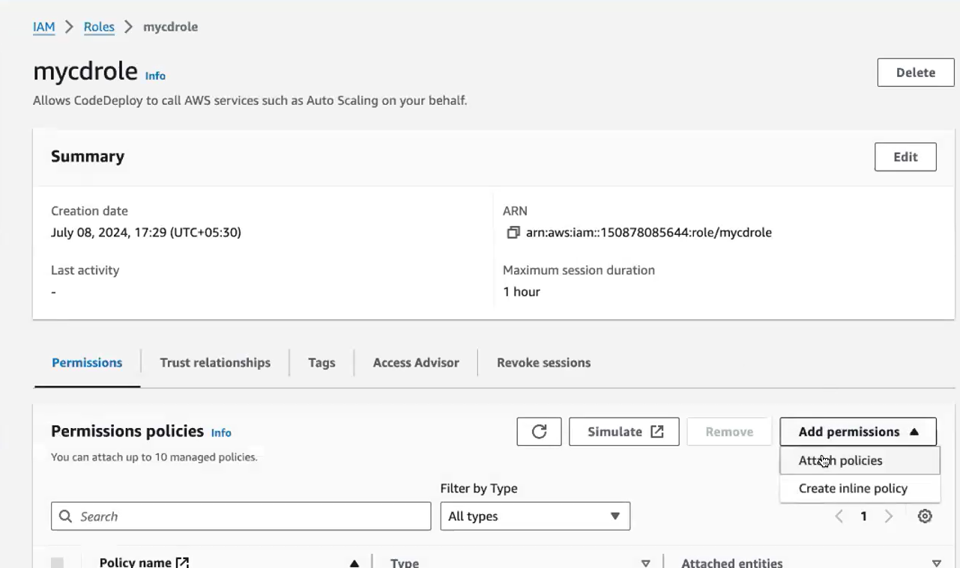

Give all the permissions .open this IAM in new tab.

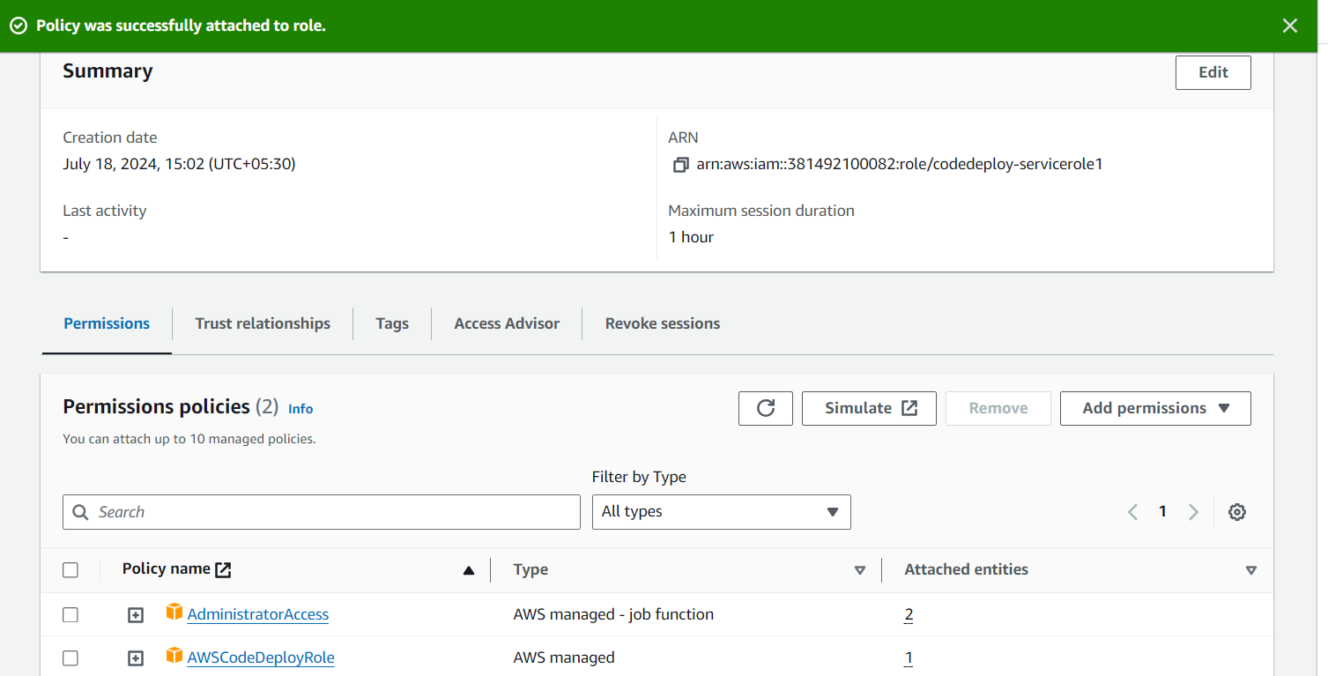

**Attach the permissions[administration access] to this roles**

U have attached it. Okay. So now we will go and attach this role. So we have created the role. So you have to attach the role here. The service role after creating the service role with all the permissions you have to attach it to your deployment of group configuration.

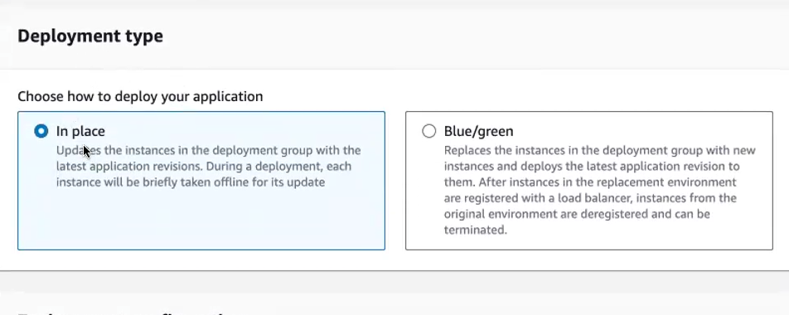

1. **in place:**

Different types of deployment strategies. If you're going for in place deployment needs, So it will what it will do it will. so it will deploy your application altogether.

1. **blue, green deployment:**

* Wherein, if you're going for blue green deployment. So now I have. I'm like maintaining one. Applic I'm running an application in my Ec2, and tomorrow I create a different version. I see I have a different. I have developed a different version of my application. And I want to replace my existing application.
* Okay? Because the real time, if you see every now and then, if you go and look for the website, amazon.com or Flipkart, or Myntra. Whatever you see every day there is a new feature added to the application. So the new feature is a new version only.
* So what we do in the Blue Green deployment model, we will be creating 2 types of environment. One is for the blue environment and another one is a green environment.
* So blue environment maintains your original. The existing application will be running in the blue environment.
* And I created another environment called as green environment my new version. I will put it inside my green environment.
* So what I will do I will test my green environment. I will perform all the real time tests in my green environment. Once that is done, if my new version is properly functioning.
* Then I will gradually move my green gradually move my application, the newer version, which is running the green environment to my blue environment. Okay? So they are asking what type of deployment strategies you wanted you can go with in place itself. So now they're asking, yeah, environmental configuration.

**Create a new ec2:**

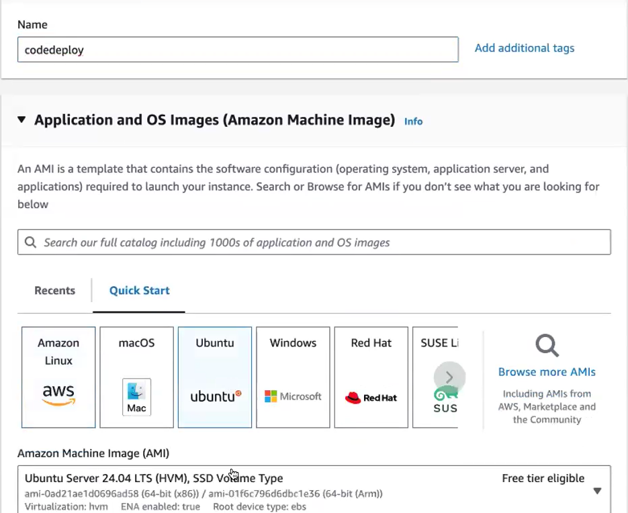

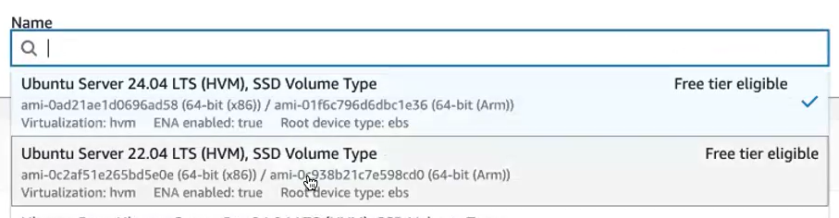

Connect that instance

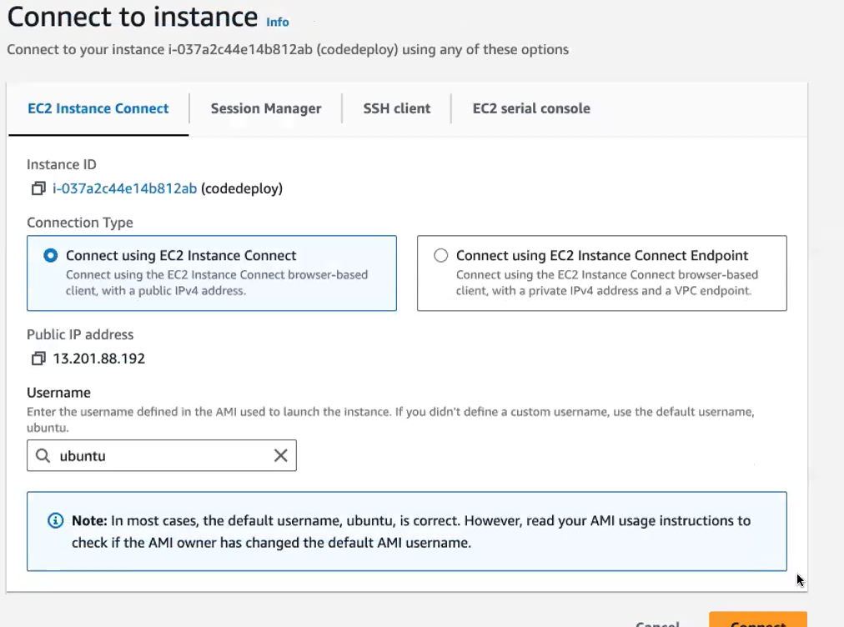

**now your code deploy has to deploy the application. What it will do. It will get the application from the Ec2. Sorry it will get the application from the previous stage. That is the artifact. So where your artifact is located, it is located in the S3 bucket. So your code deploy will get the artifact from the S3 bucket, and it will deploy to my Ec2 .**

So for doing that, I need a mediator to do that. So my code, I have to install code deploy agent inside this Ec 2 where you're deploying to that Ec 2. You have to install **code deploy agent**. Okay, so this code deploy agent will help you to deploy this application to your Ec 2. So I will also give you the code of this whole deployment. so you will get the quote from the Amazon itself. I will tell you. After finishing this.

**I will create a shell script**:

**so that with a single shell script you can install it.** done this for the client agent install. So if you're using Amazon Linux. The installation is very straightforward. You just have to run a single command. Since you are using ubuntu. Okay, ubuntu is a 3rd party operating system. So you have to. There are several steps that you have to follow to install this code.



**only thing you have to edit as the region code. If you see in my 4th line and the wget command I have given the region code as Us- East1 [this can be changed our region code can give]**

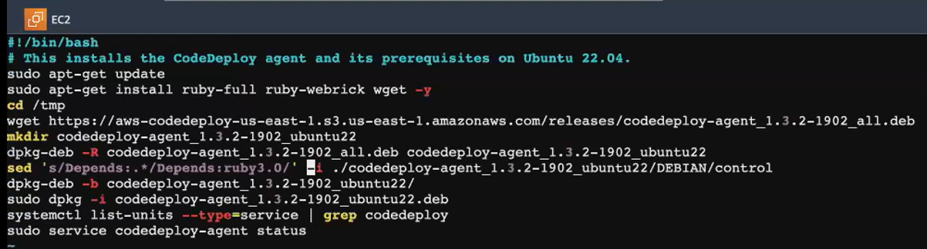

<https://docs.google.com/document/d/1PWghD1uklVI37KiR92n9ln8WEUyO6bbbkXUU_ZtC13E/edit#heading=h.x44geimrpqar>

create a cicd pipeline in aws {document link}

**want to install Code deploy agent in the window server. You have to run this command one by one.**

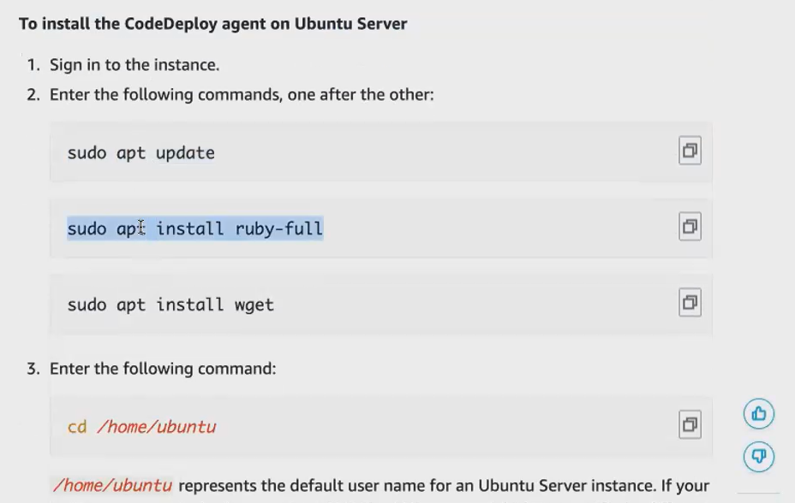



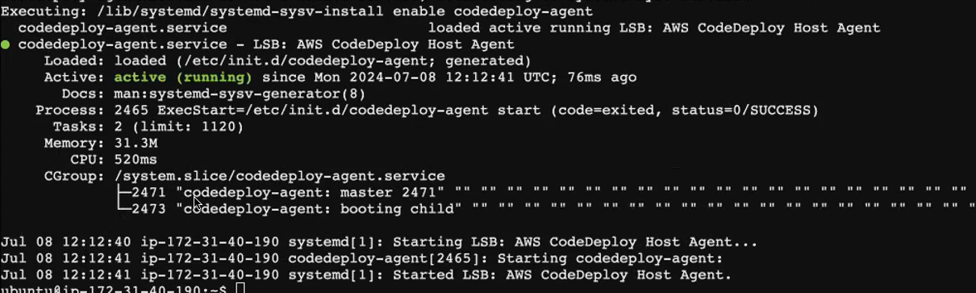

After installed.goto code deploy configuration

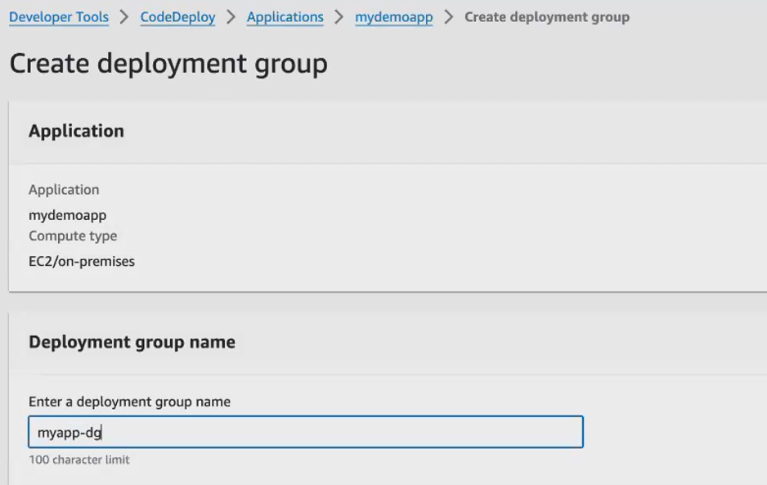

Here I have to select the ec2 where I have installed my code deploy agent. Let me refresh it. Yes, name, and the value is the name of your Ec. 2, where you have installed the Code Deploy Agent, and you can see it is matching.

It are showing the result as one unique match instance, which means this Code deploy agent can identify your Ec. 2 and it is asking agent configuration with Aws Systems manager. You can either go with now schedule and you can go. You can go with the automatic code deploy agent install if you click on only once, your code deploy agent will be automatically installed to this ec2. This is an automated way, but you can also go and manually install it Refresh that page.code deploy agent is visible.

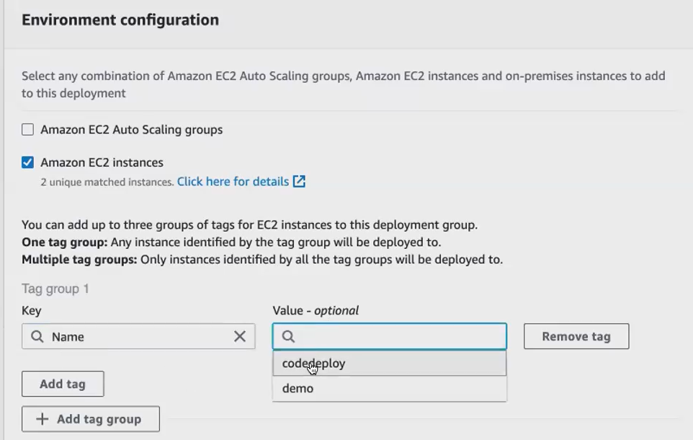

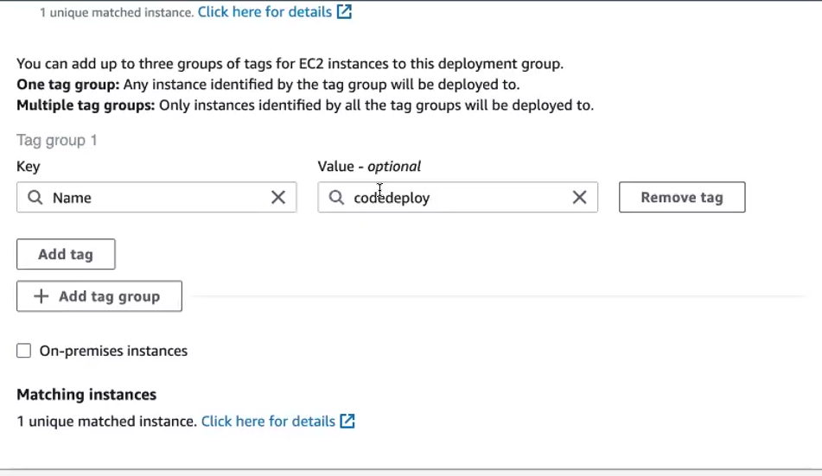

the script and deployed the Code Install the Code Deploy agent. You can either way you can go. You can ask your code deploy to de install the code deploy agent in your Ec. 2 .We click on only once. It will be installed only once, or if you're going for now and schedule updates means whenever there is a new release, it will install the code deploy agent every now and then. So now let me go with never, because I have already installed it. So I don't need the Code Deploy Agent again to be installed.

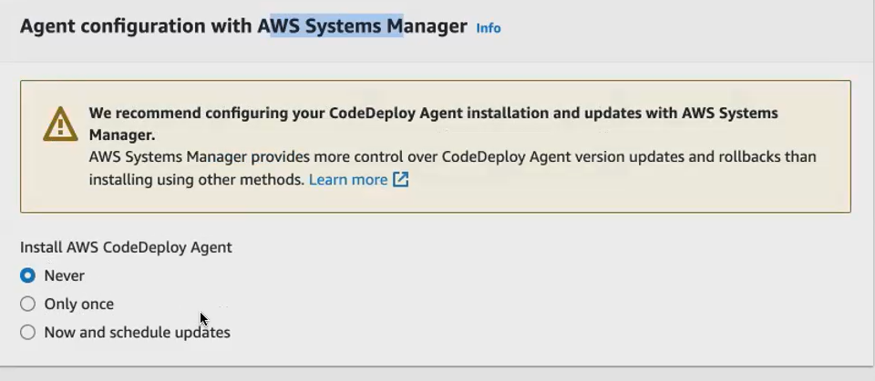

**So enable load Balancer. If you have multiple Ec 2.If your application is running in multiple Ec 2, you can go and enable load Balancer. Now, I have only one easy to machine configure, so I don't want to enable load balancer.**

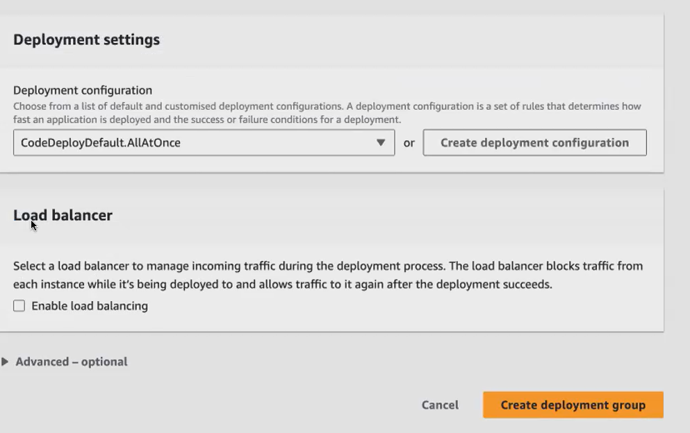

Remaining not needed ,given as per.

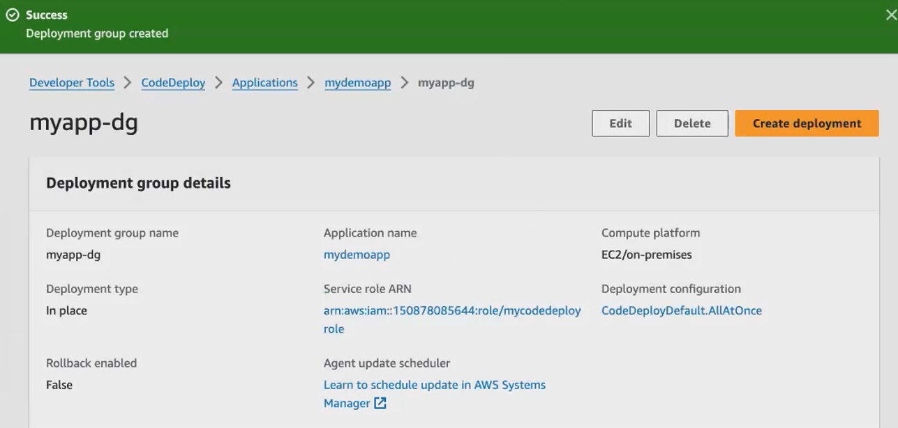

**so now, we have created the deployment group. So here I've also installed the Code Deploy agent. So now I want to let my. Now I've given permission for my code deploy to talk with the Ec. 2 .So my Ec. 2 should also have permission to connect with my code deploy agent. Okay, so what I have to do, I have to attach the permission for my Ec 2.**

You'll be creating 2 roles is don't get confused. So for code deploy.we will be creating 2 roles. One is for the code deploy itself. Another one is for your Ec 2, where you're deploying the application.

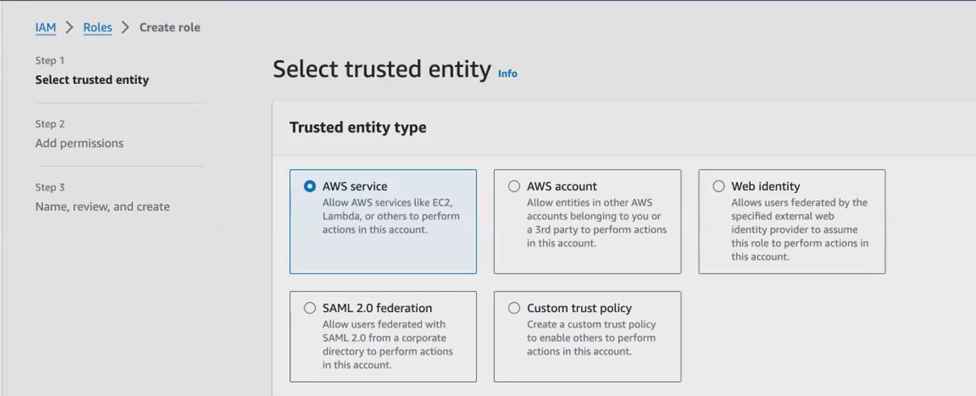

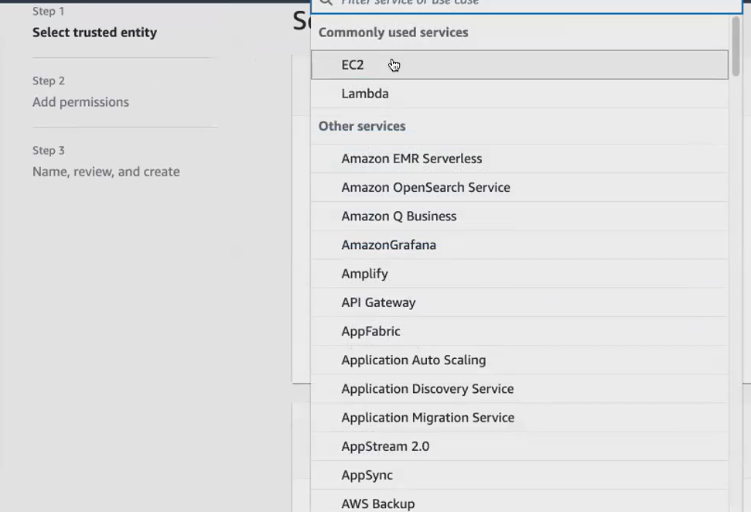

**Attach permissions for this role [give full access to ec2, s3, deploy full access, code deploy role]**

**Get into that role click attach policies.**

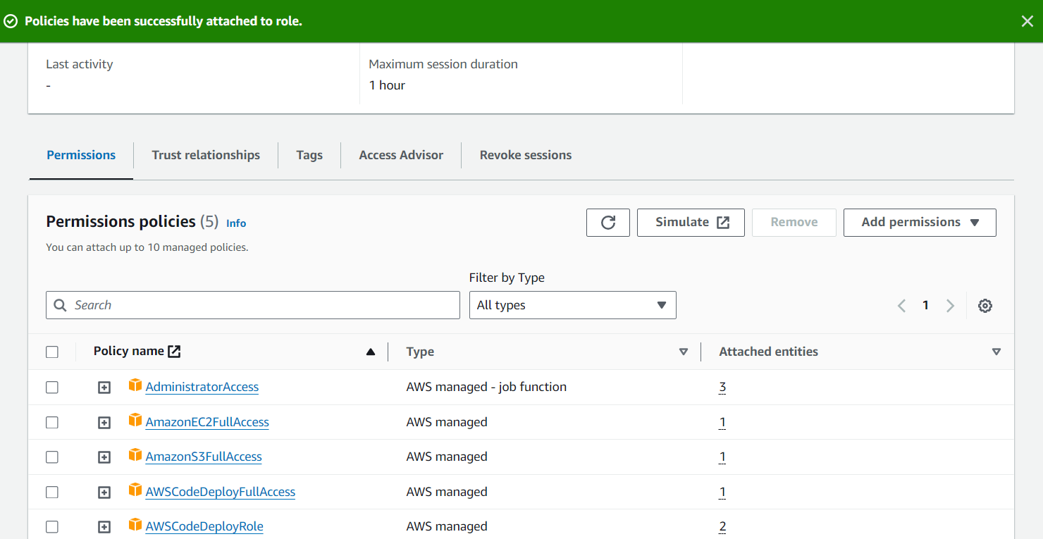

**Goto instance give modify iam role. now I have to attach this role to my Ec 2.click ec2**

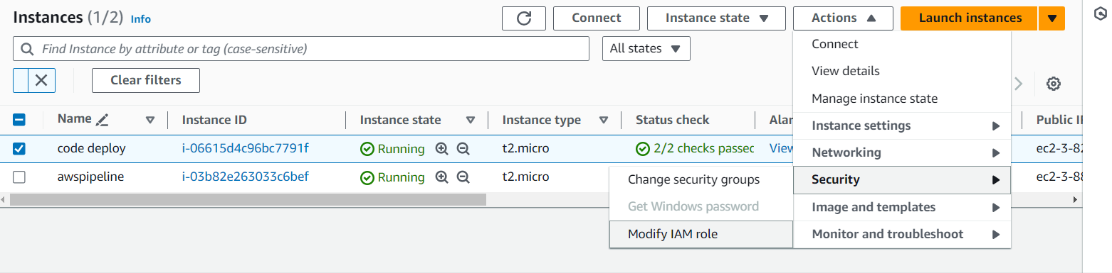

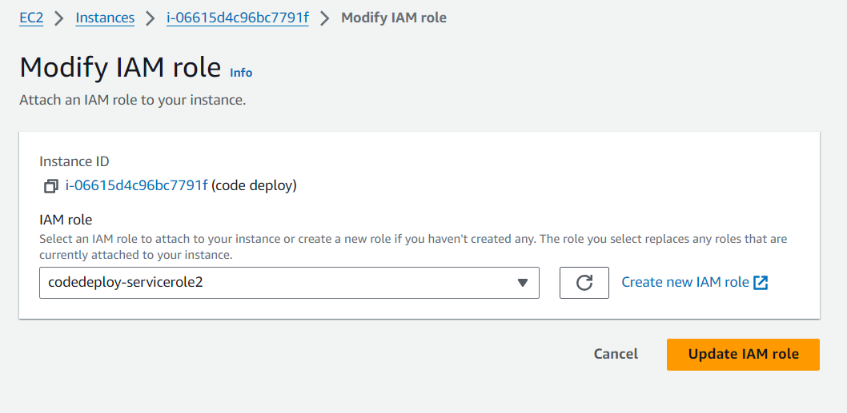

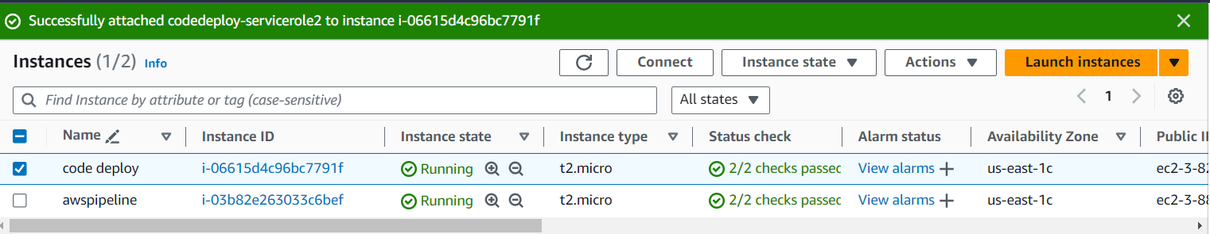

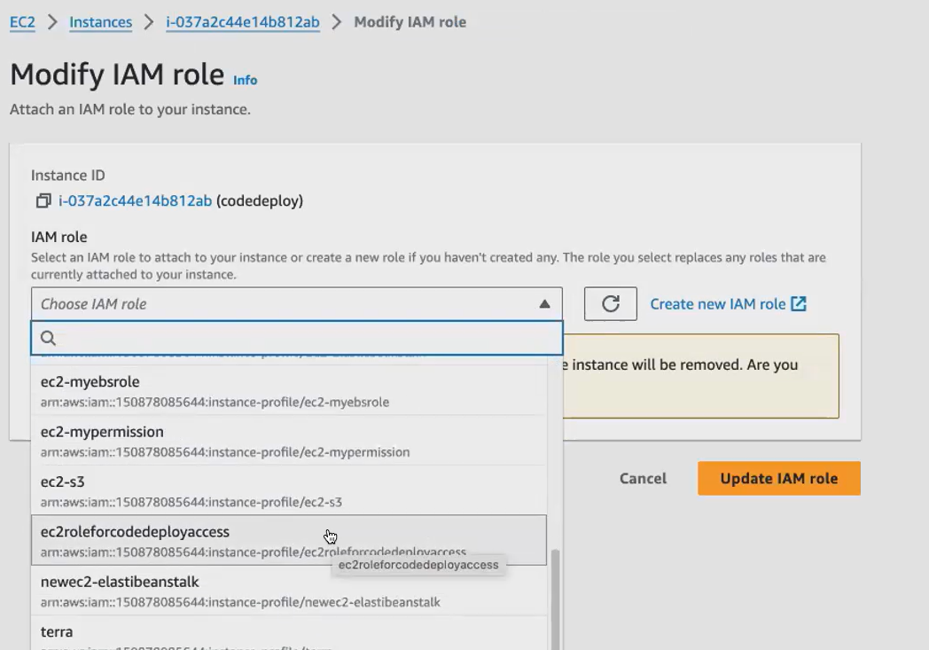

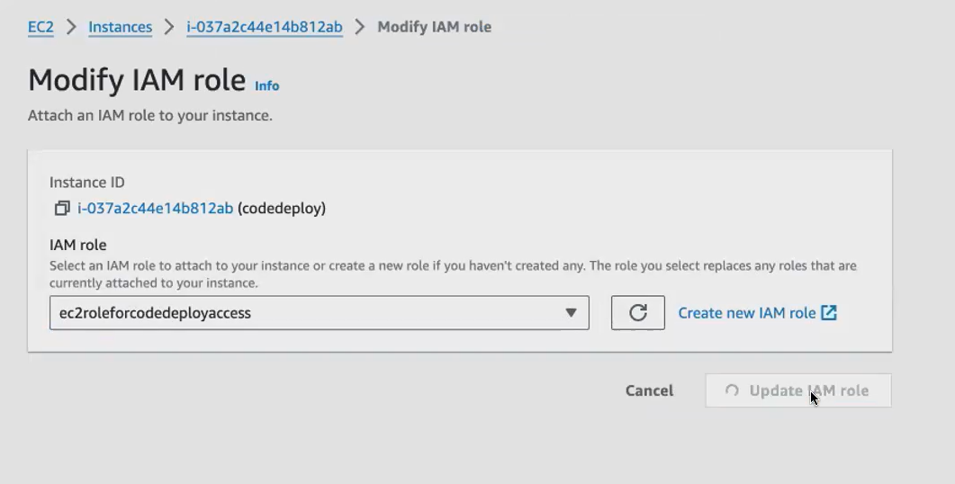

**after updating it again, go to your Ec 2, connect with your Ec 2.give this command**



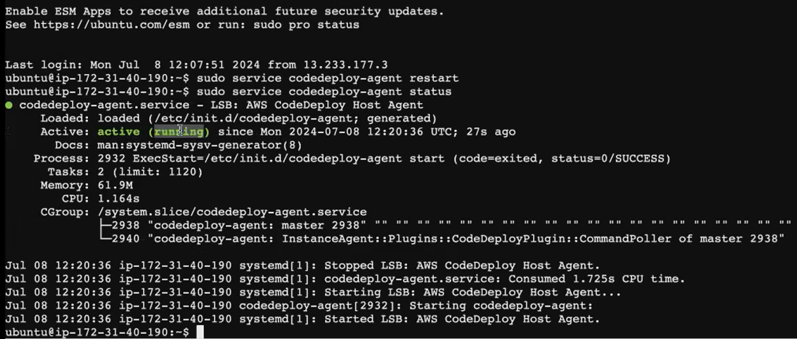

We have created all the infrastructure. But we haven't done the configuration. So for doing it, we have to create how we created a file build a process. You created a builtspec.yaml. Same way for initiating the report initiating the deployment process. You have to create a file called Appspec.yaml. appspec file did not take yaml file.so we create appspec.yml file.but builtspec file accept both yaml/yml file

**Appspec.yml file**

**iii) Appspec.yml**

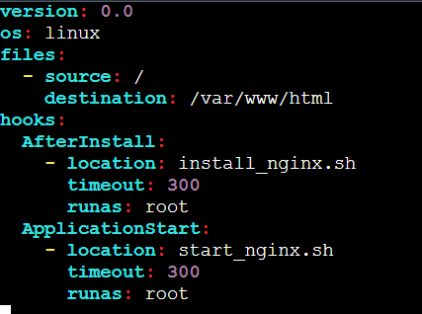

* **install_nginx.sh**

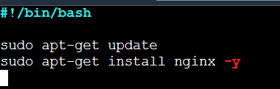

* **Start_nginx.sh:**

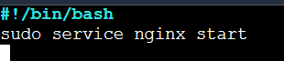





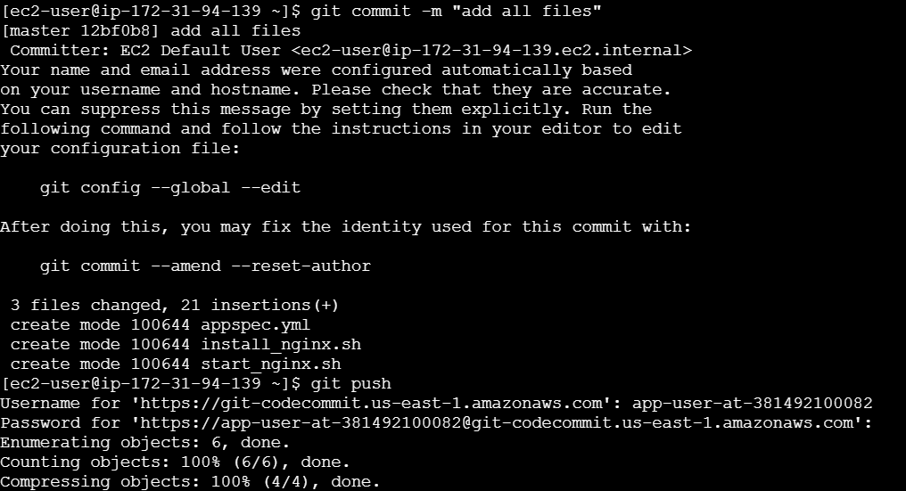

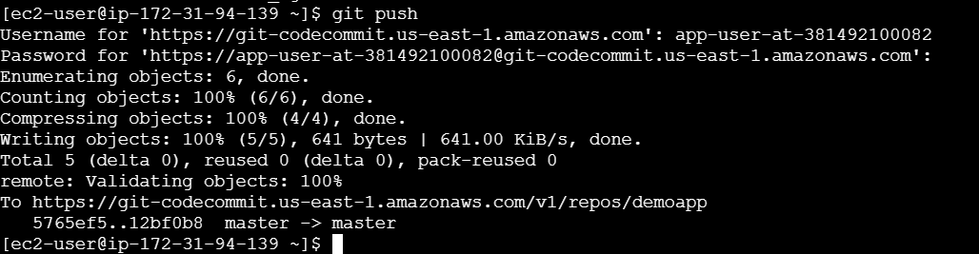

**All files written in amazon linux instance**

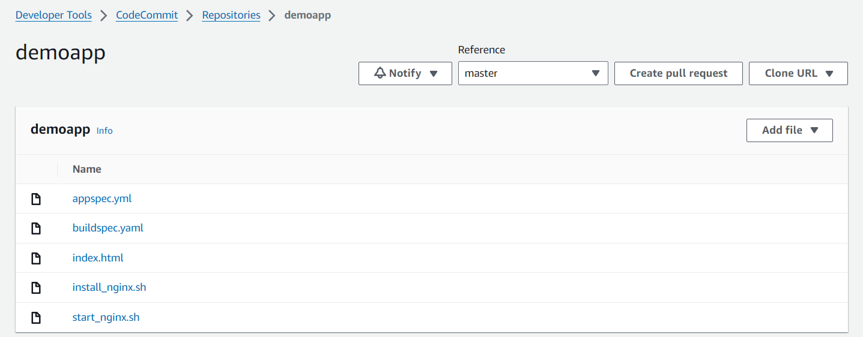

**Open the port no: 80 for code deploy ec2 instance**

**Create pipeline:**

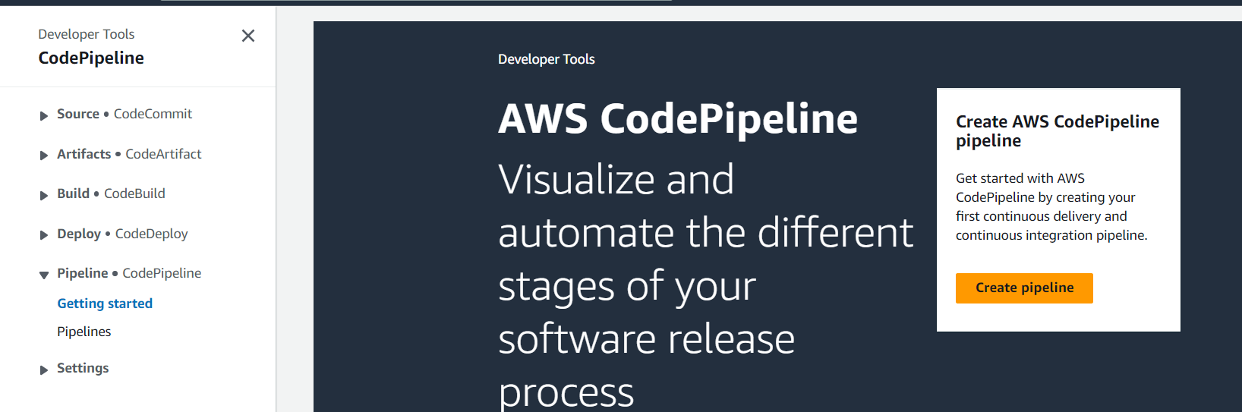

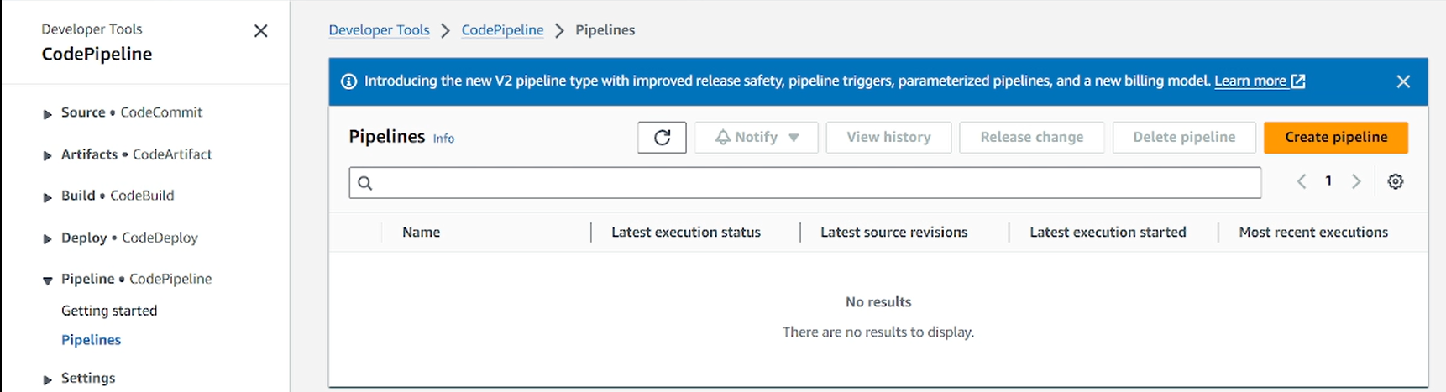

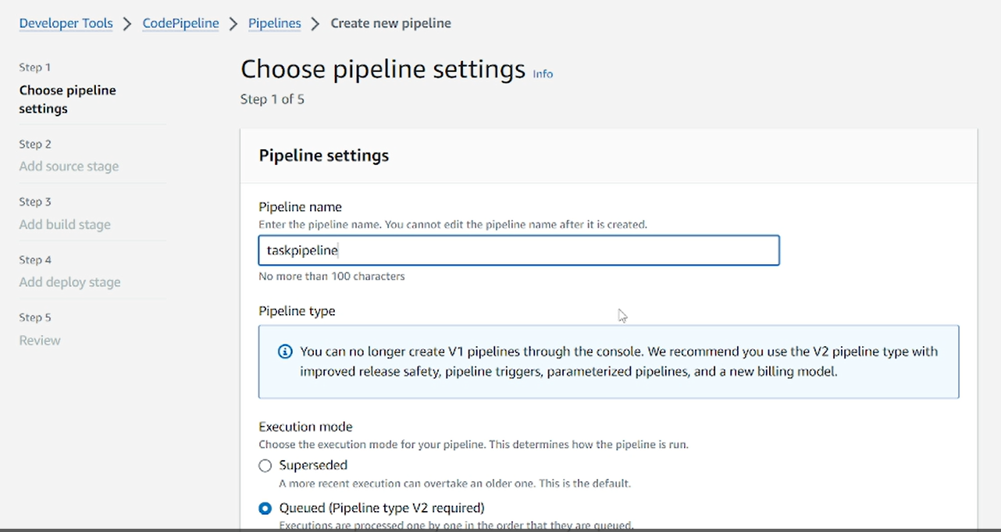

**Remaining are same .click next. pipeline role also assigned automatically**

**Select aws code commit.All names comes under [already we created]**

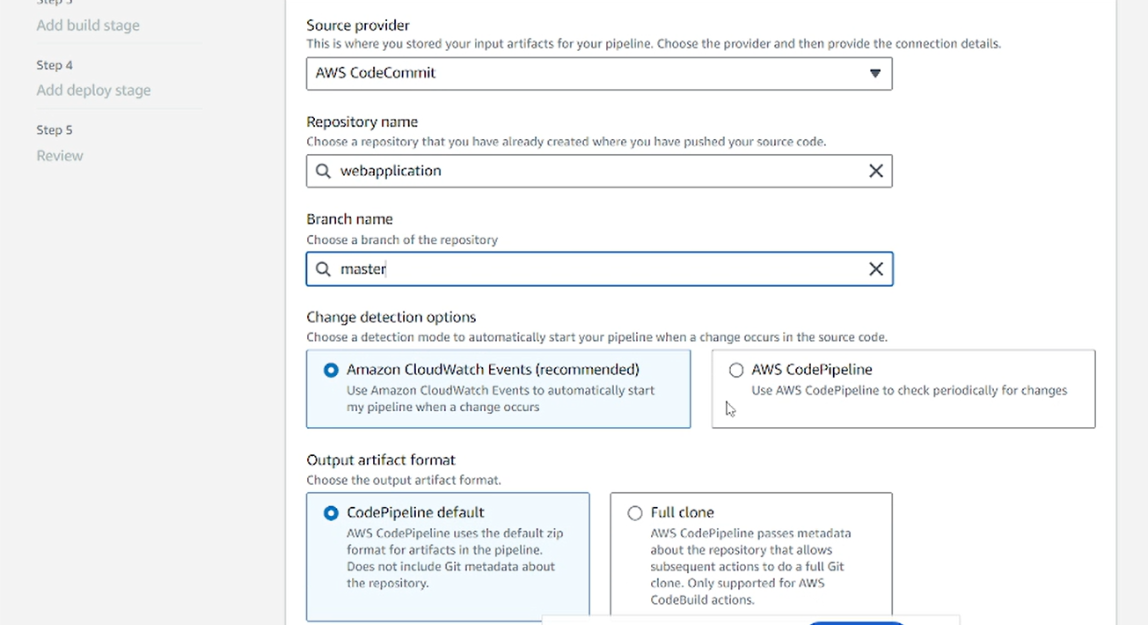

**This build stage is optional:**

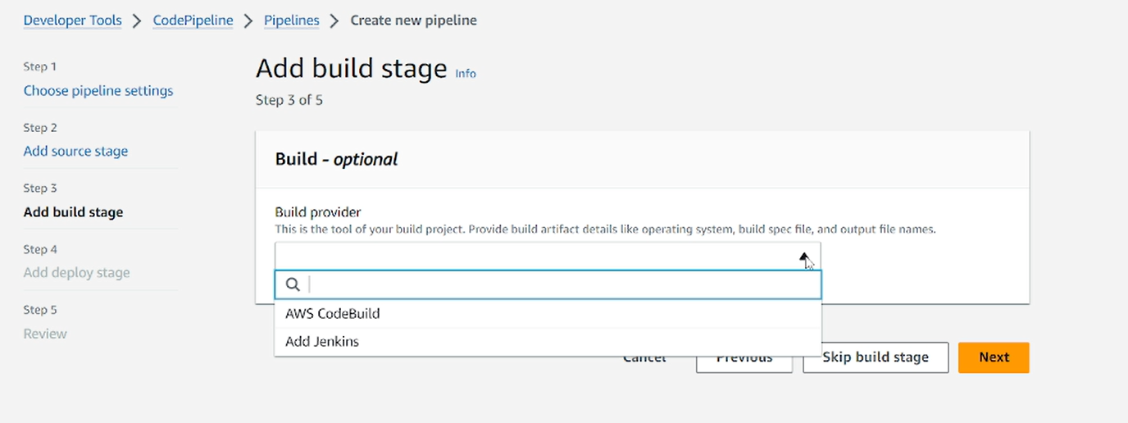

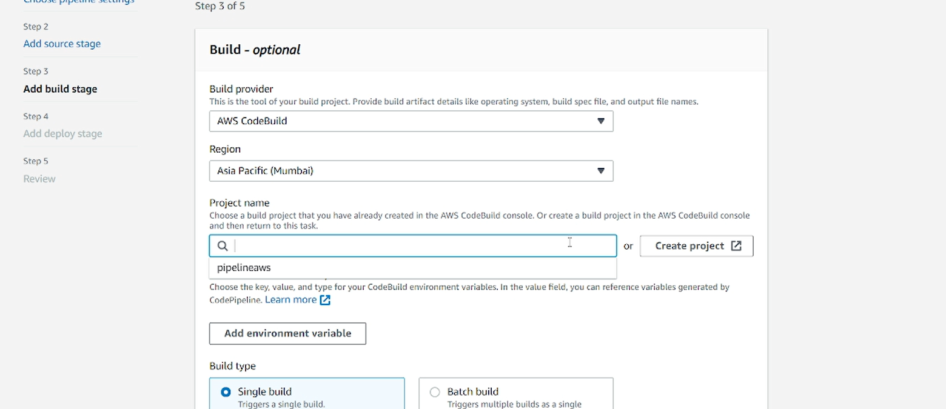

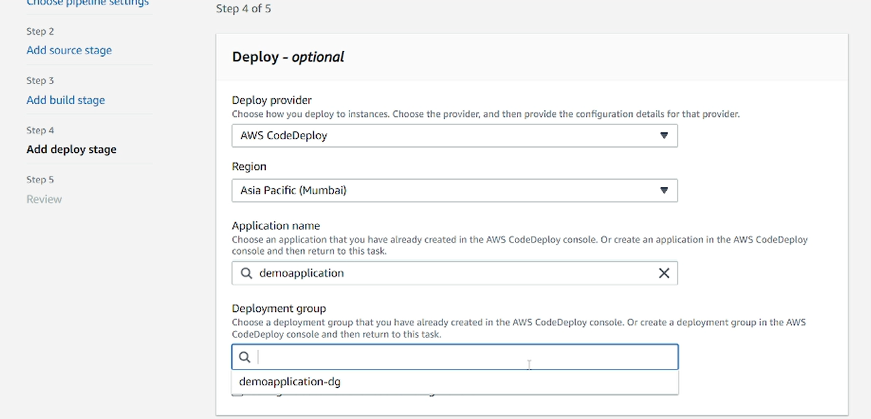

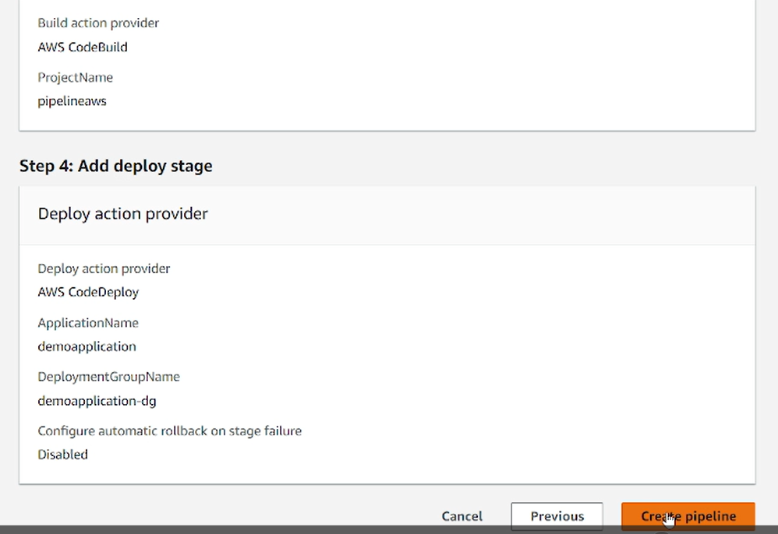

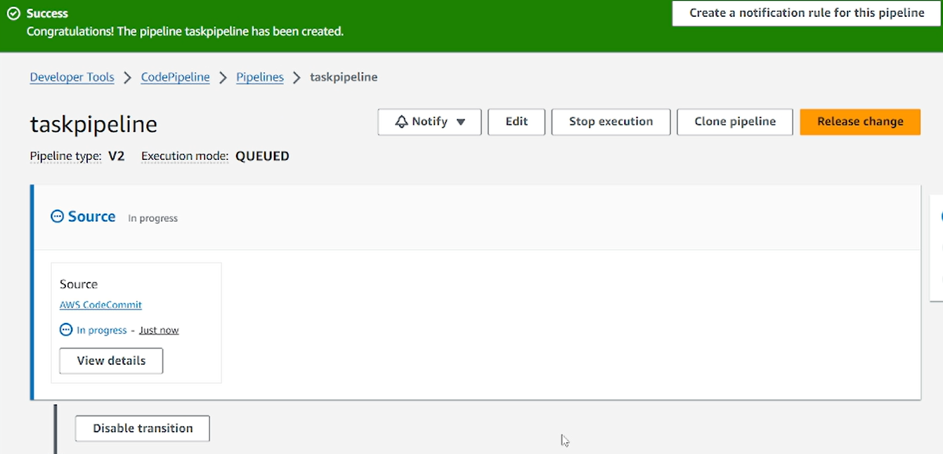

**After came to succeeded stage click view details. Where the code come like that all details shown.**

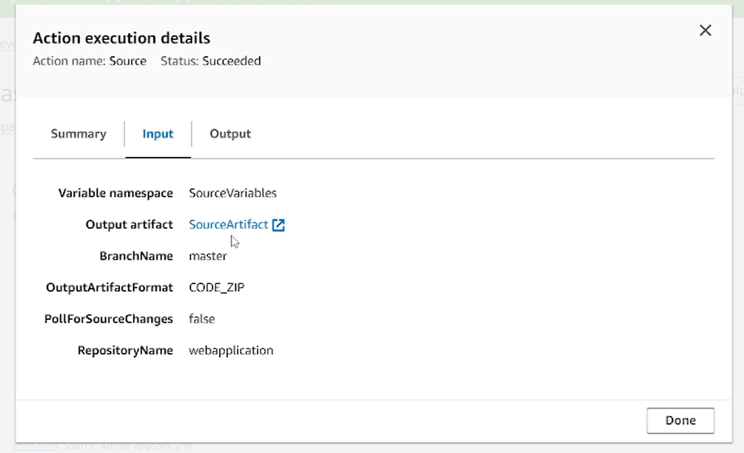

**All stages ran**

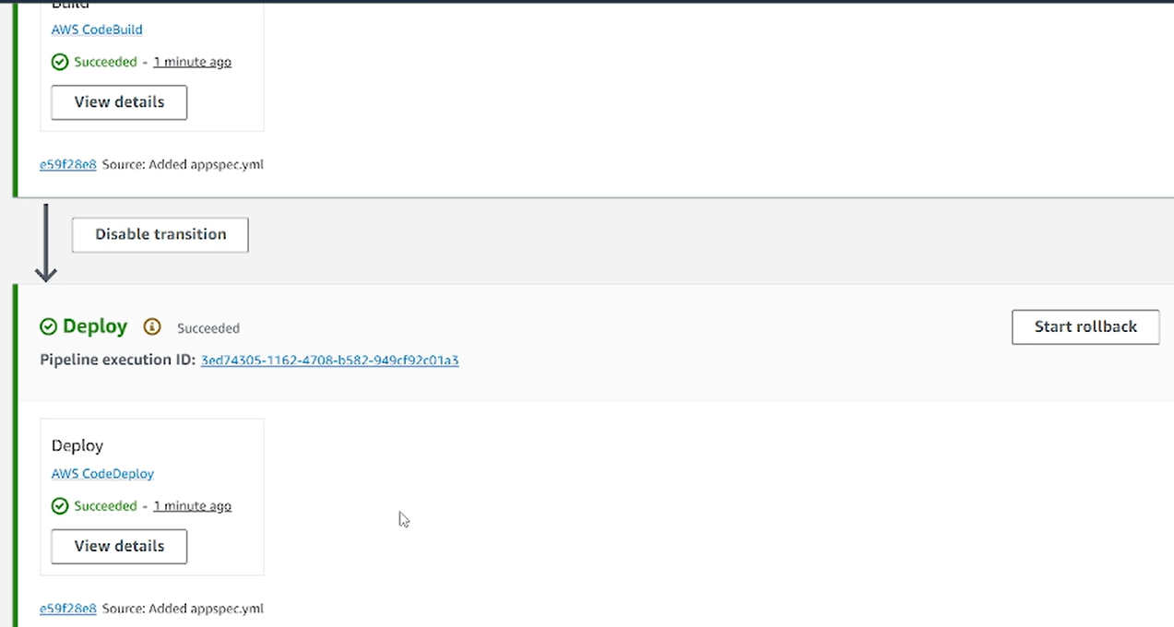

**Goto code deploy ec2.open the port no:80..copy the address run in browser.**

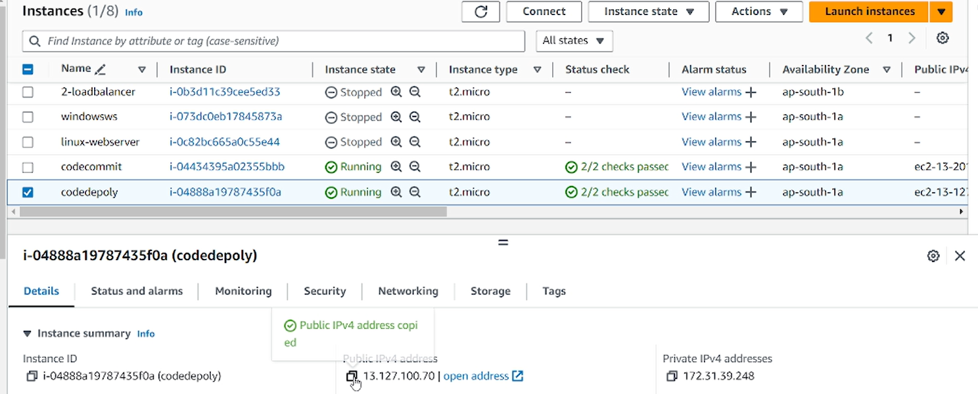

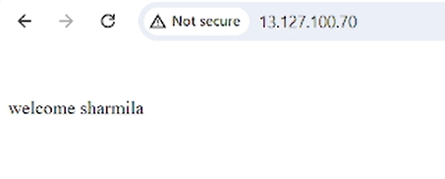

**Goto index.html that content changed. That change automatically updated in browser. Because we automate the process.**

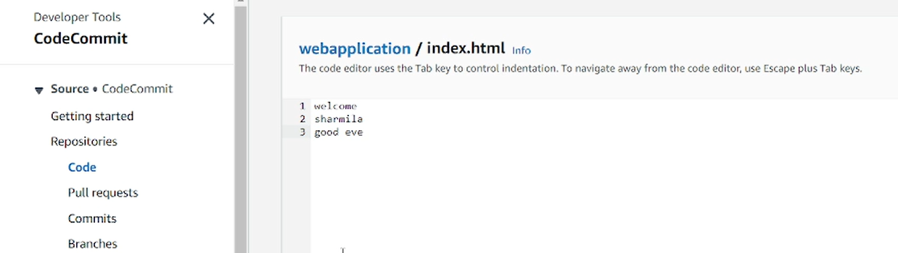

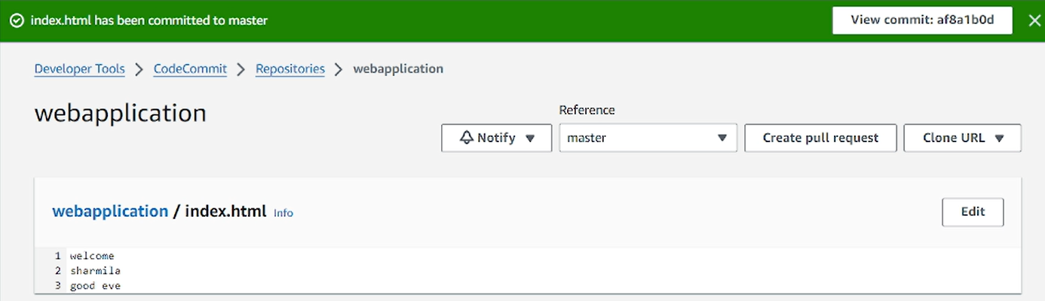

**Goto that pipeline. That blue line indicates the file is built**

